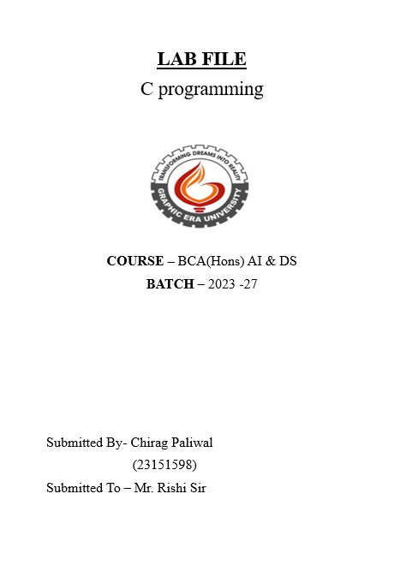

#include <stdio.h>

int main() {

printf("chirag paliwal\n");

printf("Hello world");

return 0;

}

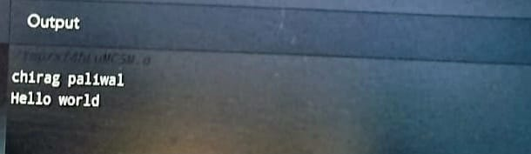

2.wap to add two numbers.

#include <stdio.h>

int main() {

int number1, number2, sum;

printf("chirag paliwal\n");

printf("Enter two integers: ");

scanf("%d %d", &number1, &number2);

sum = number1 + number2;

printf("%d + %d = %d", number1, number2, sum);

return 0;

}

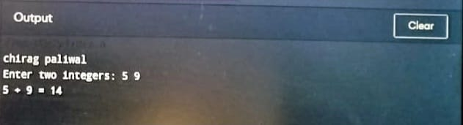

3 . wap to find area of circle.

#include <stdio.h>

int main() {

float pie = 3.14;

int radius;

printf(“chirag paliwal”);

printf("Enter The Radius of Cicle:");

scanf("%d",&radius);

printf("The radius of the circle is %d\n" , radius);

float area = (float)(pie* radius * radius);

printf("The area of the given circle is %f", area);

return 0;

}

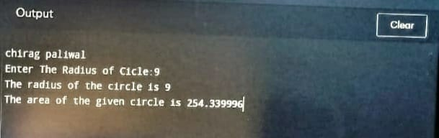

4 wap to divide two numbers?? //C Program To Divide Two Numbers

#include<stdio.h>

int main(){

int num1, num2, quotient;

printf("chirag paliwal\n");

printf("Enter first number: ");

scanf("%d", &num1);

printf("Enter second number: ");

scanf("%d", &num2);

quotient = num1 / num2;

printf("Quotient: %d", quotient);

return 0;

}

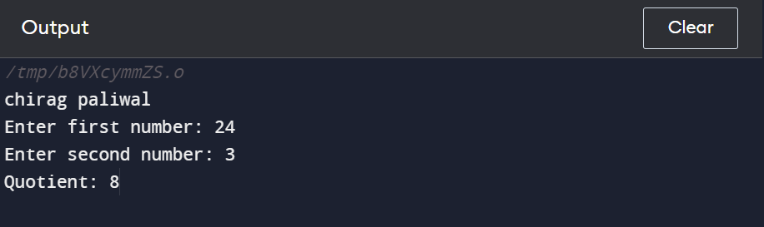

5. wap to find ASCII value.

#include <stdio.h>

int main() {

char c;

printf("chirag paliwal\n");

printf("Enter a character: ");

scanf("%c", &c);

printf("ASCII value of %c = %d", c, c);

return 0;

}

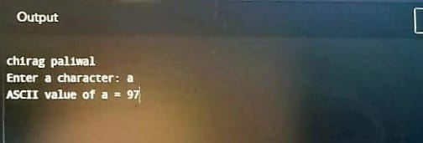

6.wap to multiply floating point numbers

#include <stdio.h>

int main() {

double a, b, product;

printf("chirag paliwal\n");

printf("Enter two numbers: ");

scanf("%lf %lf", &a, &b);

product = a * b;

printf("Product = %.2lf", product);

return 0;

}

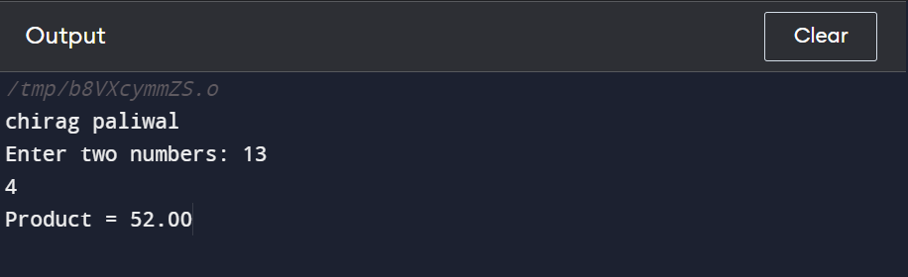

7. wap to swap two variable numbers by using third variable”?

#include <stdio.h>

int main()

{

int var1, var2, temp;

printf("chirag paliwal\n");

printf("Enter two integers \n");

scanf("%d%d", &var1, &var2);

printf("Before Swappingn First variable = %d\nSecond variable = %d \n", var1, var2);

temp = var1;

var1 = var2;

var2 = temp;

printf("After Swappingn First variable = %d\nSecond variable = %d\n", var1, var2);

return 0;

}

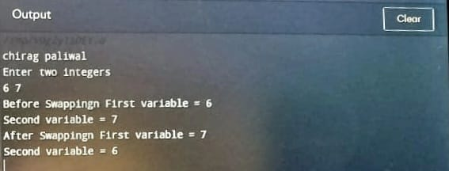

8. wap to swap two variable numbers without using third variable

#include<stdio.h>

int main()

{

int a=20,b=14;

printf("chirag paliwal\n");

printf("Before swap a=%d b=%d",a,b);

a=a+b;

b=a-b;

a=a-b;

printf("\nAfter swap a=%d b=%d",a,b);

return 0;

}

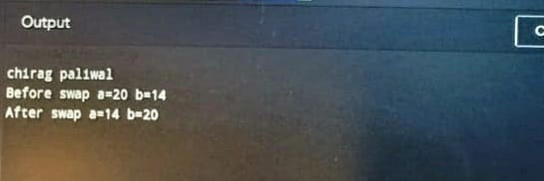

9. wap to swap three variable numbers without using third variable

#include<stdio.h>

void main()

{

int a,b,c;

printf("chirag paliwal\n");

printf(" Enter values of a, b and c \n");

scanf("%d %d %d",&a,&b,&c);

printf("\n a = %d",a);

printf("\n b = %d",b);

printf("\n c = %d",c);

a=a+b+c;

b=a-b-c;

c=a-b-c;

a=a-b-c;

printf("\n After swapping their values are as below -");

printf("\n a = %d",a);

printf("\n b = %d",b);

printf("\n c = %d",c);

return 0;

}

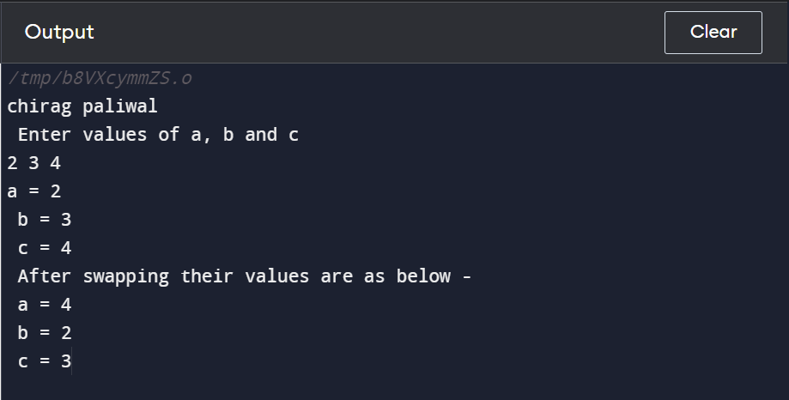

10.wap to find area of triangle

#include <stdio.h>

void main()

{

float base,height;

printf("chirag paliwal\n");

printf("Enter Base and Height: ");

scanf("%f %f",&base,&height);

float area = (base * height) / 2;

printf("Area of Triangle is %0.2f",area);

return 0;

}

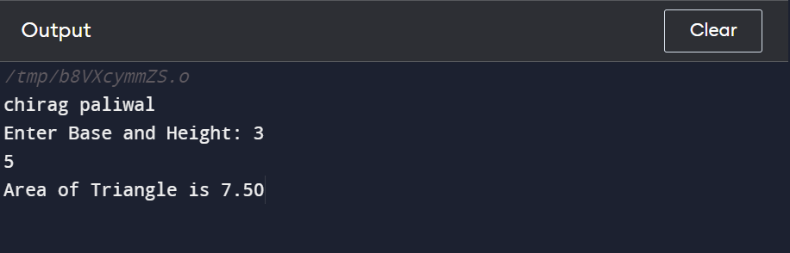

11.wap to find area of square

#include<stdio.h>

int main() {

int side, area;

printf("chirag paliwal\n");

printf("\nEnter the Length of Side : ");

scanf("%d", &side);

area = side * side;

printf("\nArea of Square : %d", area);

return (0);

}

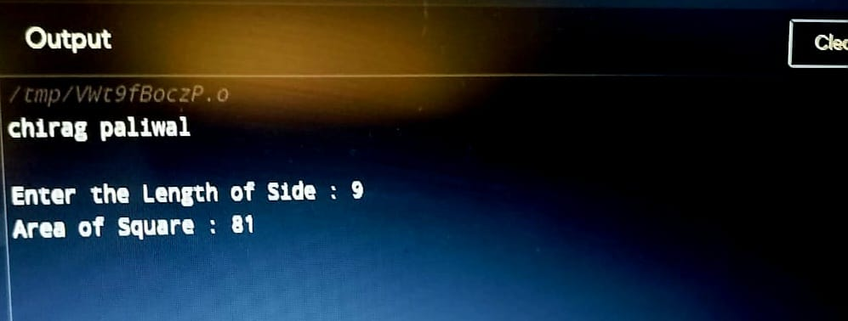

12.wap to find area of triangle

#include <stdio.h>

int main()

{

float height, width;

float area;

printf("chirag paliwal\n");

printf("Enter height and width of the given triangle:\n ");

scanf("%f%f", &height, &width);

area = 0.5 * height * width;

printf("Area of right angled triangle is: %.3f\n", area);

return 0;

}

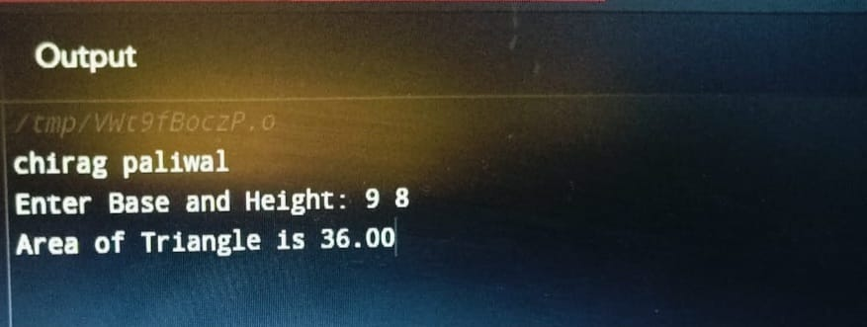

13.wap to find volume and area of cube

#include <stdio.h>

int main()

{

float side, surfacearea, volume;

printf("chirag paliwal\n");

printf("Enter the length of a side \n");

scanf("%f", &side);

surfacearea = 6.0 * side * side;

volume = side*side*side;

printf("Surface area = %6.2f and Volume =%6.2f \n", surfacearea,

volume);

return 0;

}

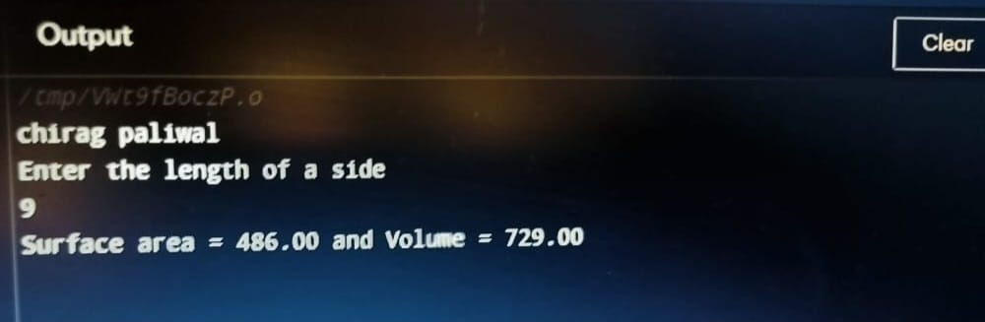

14.wap to find area and volume and area of cuboid

#include <stdio.h>

int main(){

float length, width, height, surfaceArea;

printf("chirag paliwal\n");

printf("Enter length width and height of cuboid\n");

scanf("%f %f %f", &length,

&width, &height);

surfaceArea = 2*(length*width + width*height

+ height*length);

printf("Total surface area of Cuboid : %0.4f\n",

surfaceArea);

return 0;

}

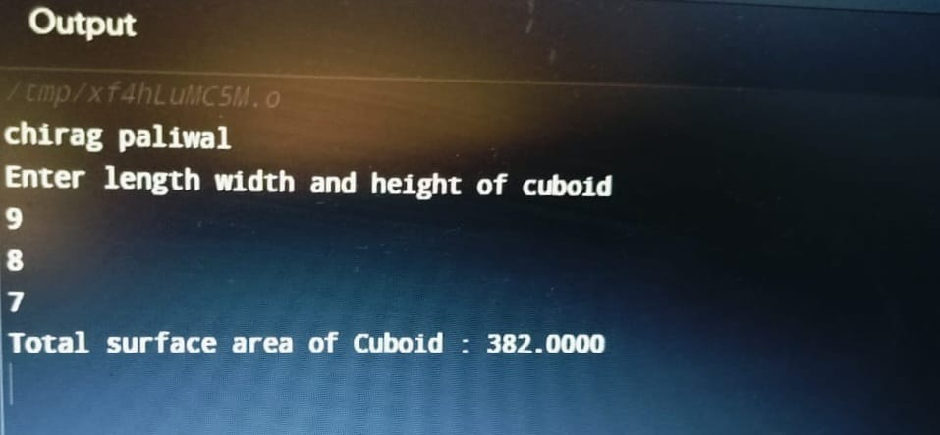

15.wap to find largest number by using logical AND operator

#include<stdio.h>

int main()

{

int A, B, C;

printf("chirag paliwal\n");

printf("Enter the numbers A, B and C: ");

scanf("%d %d %d", &A, &B, &C);

if (A >= B && A >= C)

printf("%d is the largest number.", A);

else if (B >= A && B >= C)

printf("%d is the largest number.", B);

else

printf("%d is the largest number.", C);

return 0;

}

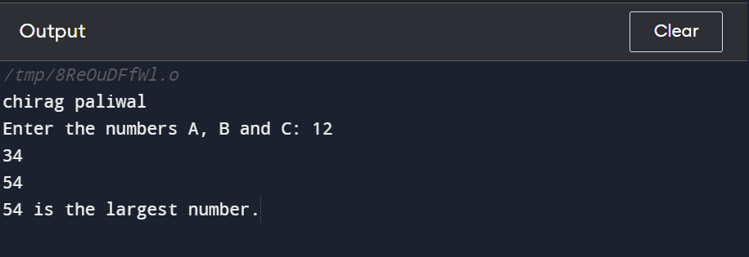

16. WAP to validate the username and password entered by the user is correct or not using the predefined username and password

#include<stdio.h>

void main()

{

int id;

int pass;

printf("Enter Your id:\n");

scanf("%d",&id);

if(id=-1010)

{

printf("Enter your password: \n");

scanf("%d", &pass);

if(pass==1100)

{

printf("Chiirag Paliwal\n");

}

}

}

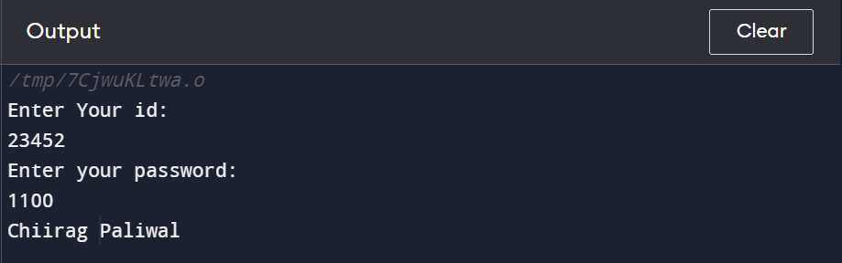

17. WAP to input the positive number from the user to perform the Left shift operator.

#include<stdio.h>

int main()

{

int num;

printf("\nChiirag Paliwal\n");

printf("enter a positive no: ");

scanf("%d", &num);

num==(num<<2);

printf("\n after shifting the binary bits to the left side: ");

printf("\n the new value of the variable num = %d", num);

return 0;

}

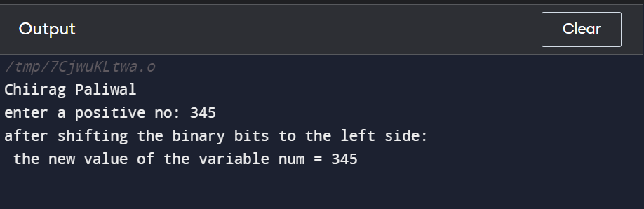

18. WAP to input the positive number from the user to perform the Right shift operator.

#include<stdio.h>

int main()

{

int num;

printf("enter a positive no: ");

scanf("%d", &num);

num==(num>>2);

printf("\n after shifting the binary bits to the right side: ");

printf("\n the new value of the variable num = %d", num);

return 0;

}

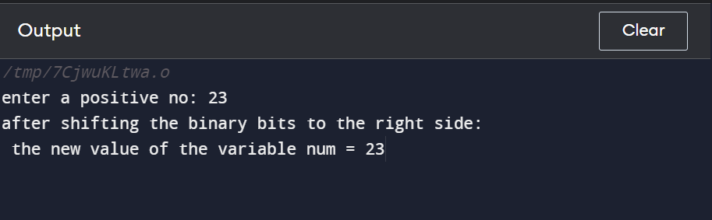

20. WAP to perform the pre increment and pre decrement operator on two integers and print both original value and updated value.

#include <stdio.h>

int main() {

int num1, num2;

printf("\nChiirag Paliwal\n");

printf("Enter the first integer: ");

scanf("%d", &num1);

printf("Enter the second integer: ");

scanf("%d", &num2);

int preIncNum1 = ++num1;

int preDecNum2 = --num2;

printf("Original value of num1: %d\n", num1);

printf("Updated value of num1 (after pre-increment): %d\n", preIncNum1);

printf("Original value of num2: %d\n", num2);

printf("Updated value of num2 (after pre-decrement): %d\n", preDecNum2);

return 0;

}

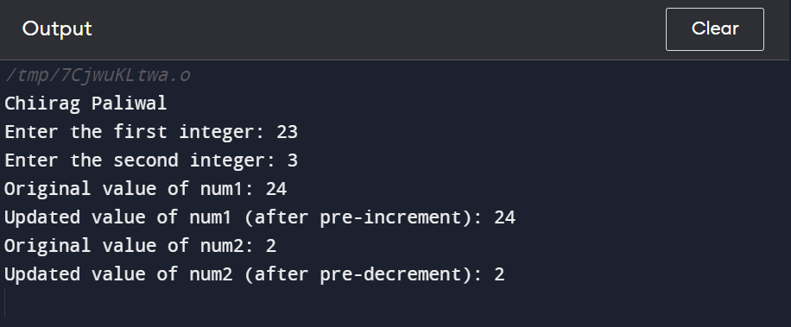

21. WAP for an integer number and to check whether it is divisible by 9 or 7 using OR logical operator

#include <stdio.h>

int main() {

int num;

printf("\nChiirag Paliwal\n");

printf("Enter an integer: ");

scanf("%d", &num);

if (num % 9 == 0 || num % 7 == 0) {

printf("%d is divisible by either 9 or 7.\n", num);

} else {

printf("%d is not divisible by either 9 or 7.\n", num);

}

return 0;

}

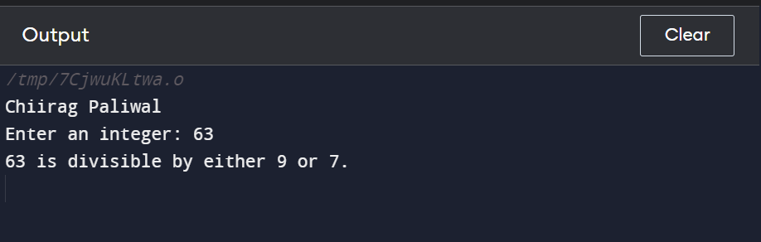

22. WAP to identify gender in single character and print full gender (Ex: if input is 'M' or 'm' – it should print "Male")

#include <stdio.h>

int main() {

char gender;

printf("\nChiirag Paliwal\n");

printf("Enter a single character ('M' or 'm' for Male, 'F' or 'f' for Female): ");

scanf(" %c", &gender);

switch (gender) {

case 'M':

case 'm':

printf("Male\n");

break;

case 'F':

case 'f':

printf("Female\n");

break;

default:

printf("Unknown gender\n");

}

return 0;

}

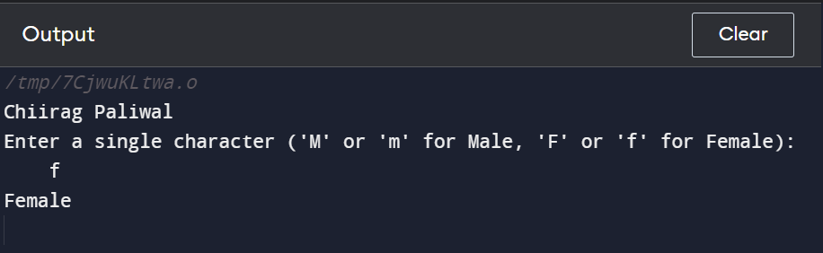

23.write c program, to print all natural numbers in reverse.

#include <stdio.h>

int main()

{

int i, start;

printf("chirag paliwal\n");

printf("Enter starting value: ");

scanf("%d", &start);

for(i=start; i>=1; i--)

{

printf("%d\n", i);

}

return 0;

}

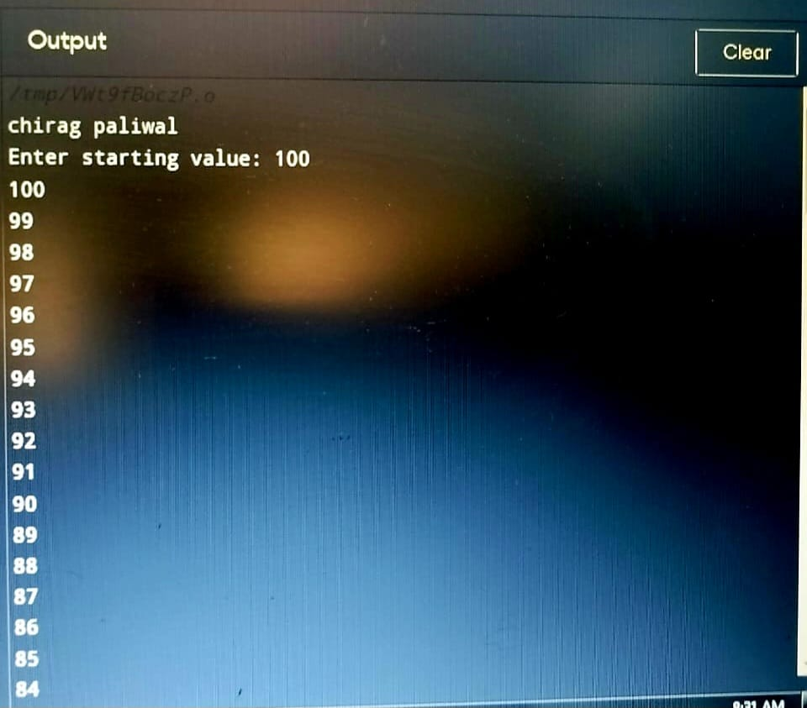

24.write a program to print all alphabet a to z.

#include <stdio.h>

int main()

{

char ch;

printf("chirag paliwal\n");

printf("Alphabets from a - z are: \n");

for(ch='a'; ch<='z'; ch++)

{

printf("%c\n", ch);

}

return 0;

}

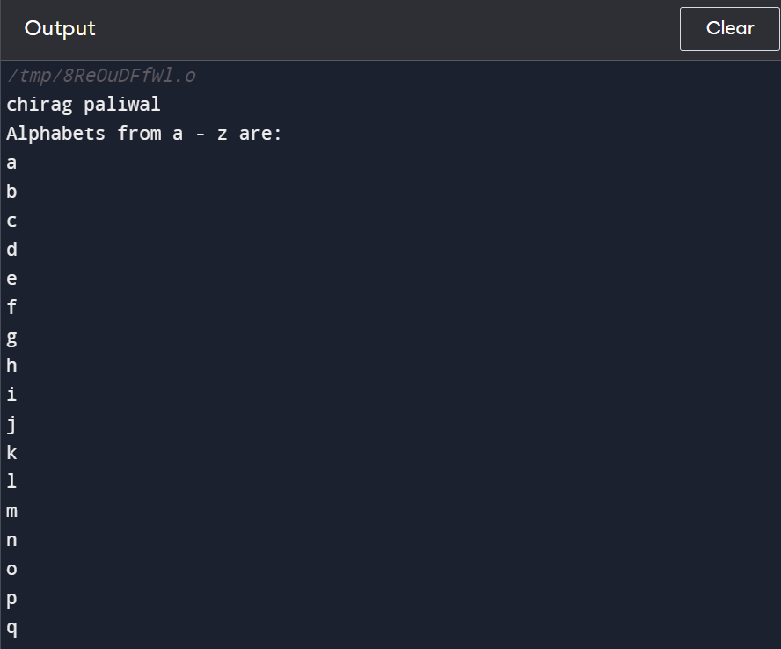

25.Write a c program to print all natural numbers.

#include <stdio.h

int main()

{

int i, n;

printf("chirag paliwal\n");

printf("Enter any number: ");

scanf("%d", &n);

printf("Natural numbers from 1 to %d : \n", n);

for(i=1; i<=n; i++)

{

printf("%d\n", i);

}

return 0;

}

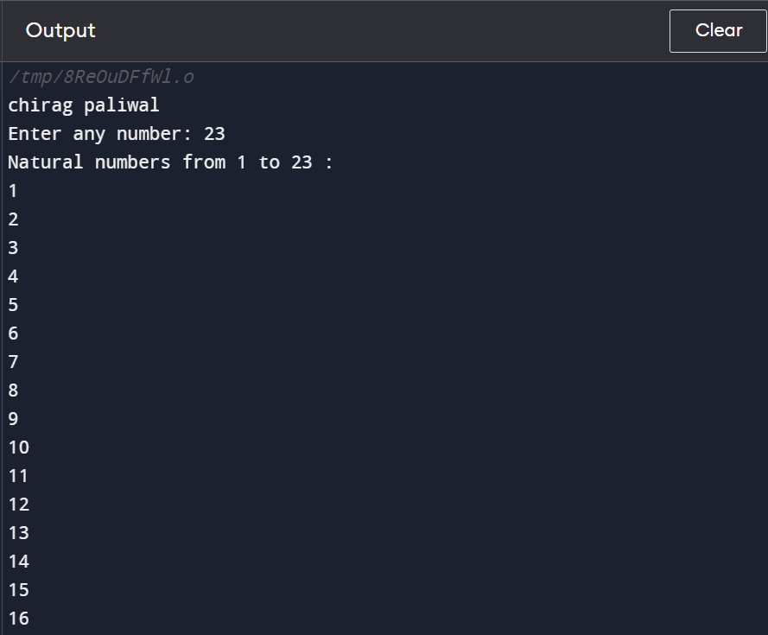

26. program to print all even number between 1 to 100

#include <stdio.h>

int main(){

printf("chirag paliwal\n");

for (int i = 2; i <= 100; i++){

if (i % 2 == 0){

printf("%d\n", i);

}

}

return 0;

}

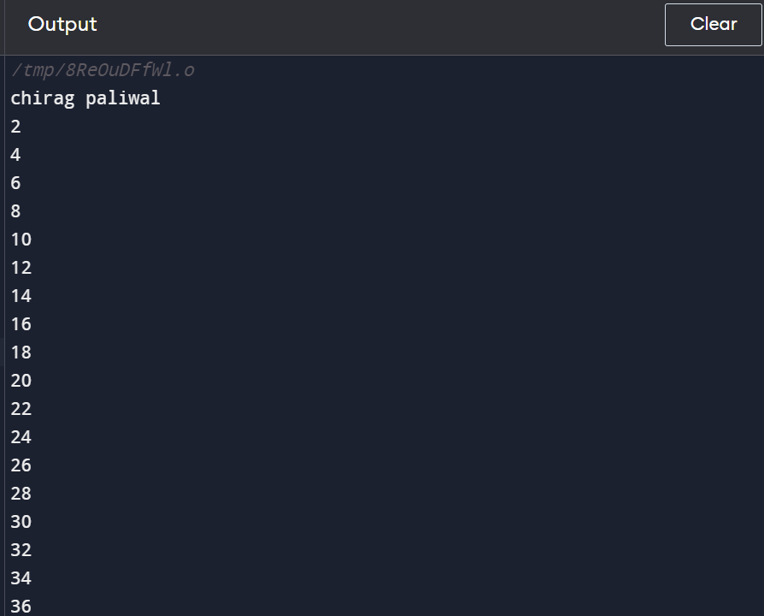

27. program to print all odd number between 1 to 100

int main()

{

int i, n;

printf("chirag paliwal\n");

printf("Print odd numbers till: ");

scanf("%d", &n);

printf("All odd numbers from 1 to %d are: \n", n);

for(i=1; i<=n; i++)

{

if(i%2!=0)

{

printf("%d\n", i);

}

}

return 0;

}

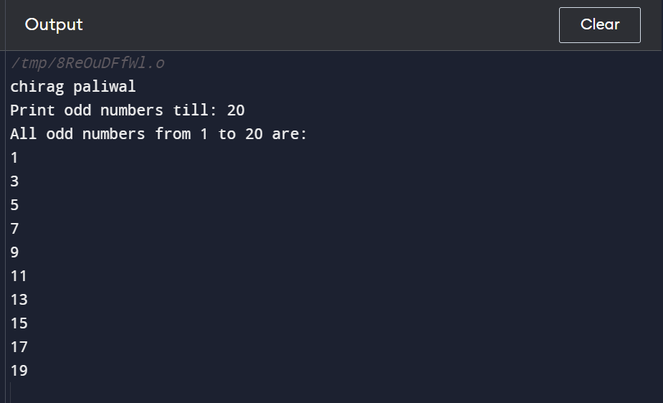

28. c program for add number 1 to n

#include <stdio.h>

int main()

{

int n,i;

int sum = 0;

printf("chirag paliwal\n");

printf("Enter a number: ");

scanf("%d",&n);

for(i=1;i<=n;i++)

{

sum = sum + i;

}

printf("The sum of first n numbers is %d",sum);

return 0;

}

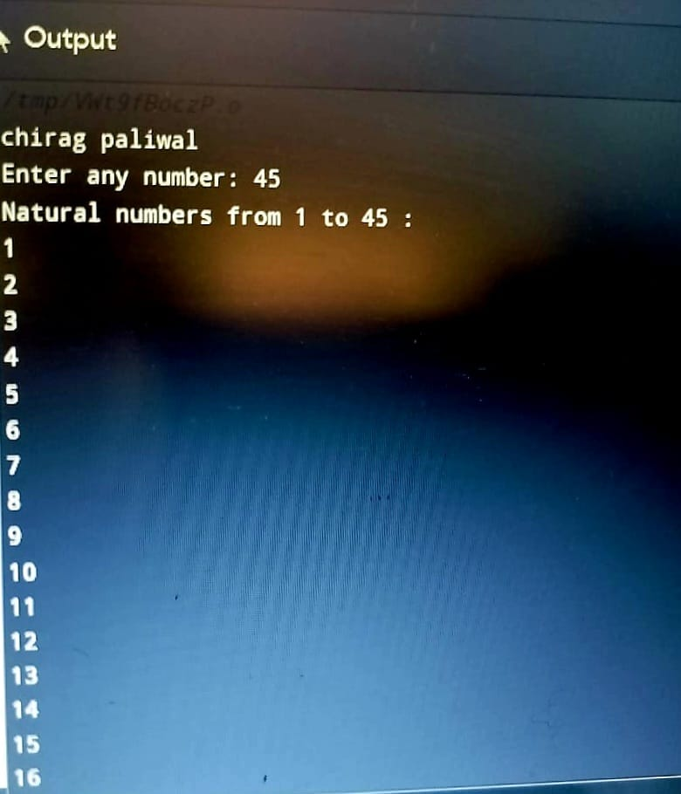

29.write a c program to find sum of all even number between 1 to n.

int main()

{

int i, n, sum=0;

printf("chirag paliwal\n");

printf("Enter upper limit: ");

scanf("%d", &n);

for(i=2; i<=n; i+=2)

{

sum += i;

}

printf("Sum of all even number between 1 to %d = %d", n, sum);

return 0;

}

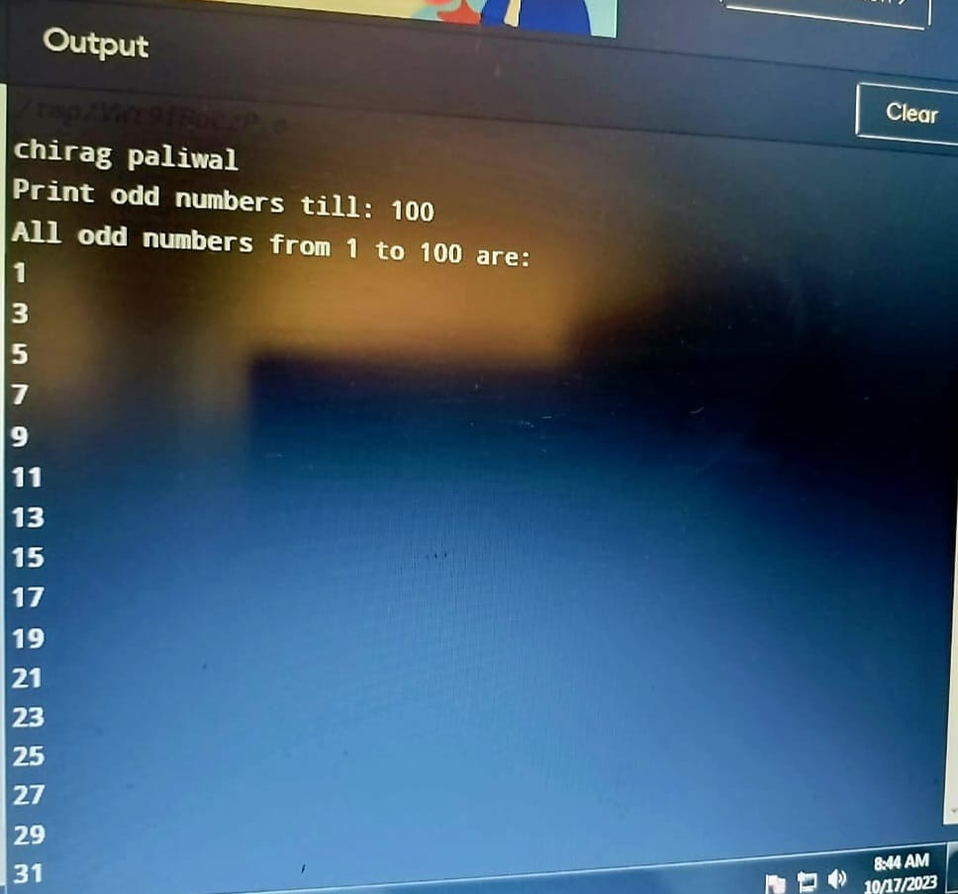

30. write a c program to find sum of all odd number between 1 to n

#include <stdio.h>

int main()

{

int i, n, sum=0;

printf("chirag paliwal\n");

printf("Enter upper limit: ");

scanf("%d", &n);

for(i=1; i<=n; i+=2)

{

sum += i;

}

printf("Sum of odd numbers = %d", sum);

return 0;

}

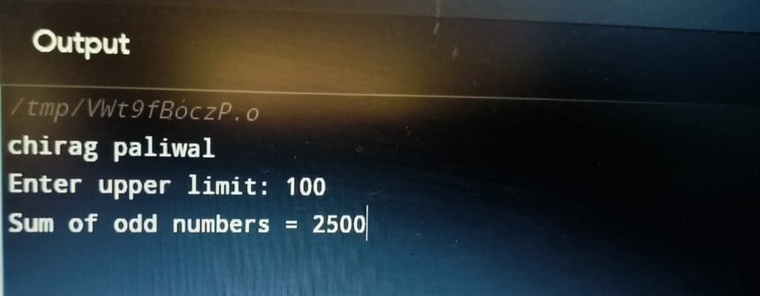

31.write a c program to print multiplication table of any number.

#include <stdio.h>

void main()

{

int j,n;

printf("chirag paliwal\n");

printf("Input the number (Table to be calculated) : ");

scanf("%d",&n);

printf("\n");

for(j=1;j<=10;j++)

{

printf("%d X %d = %d \n",n,j,n*j);

}

}

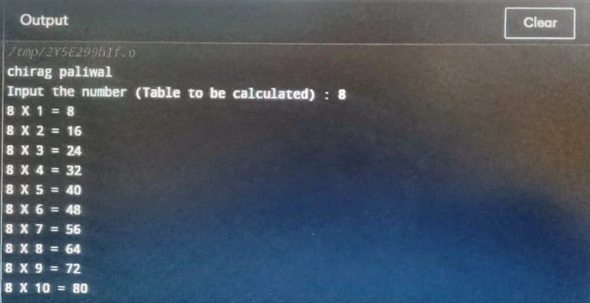

32 write a c program to count a number of digits in numbers

#include <stdio.h>

int main()

{

int n;

int count=0;

prin tf("chirag paliwal\n");

printf("Enter a number:\n");

scanf("%d",&n);

while(n!=0)

{

n=n/10;

count++;

}

printf("\nThe number of digits in an integer is : %d",count);

return 0;

}

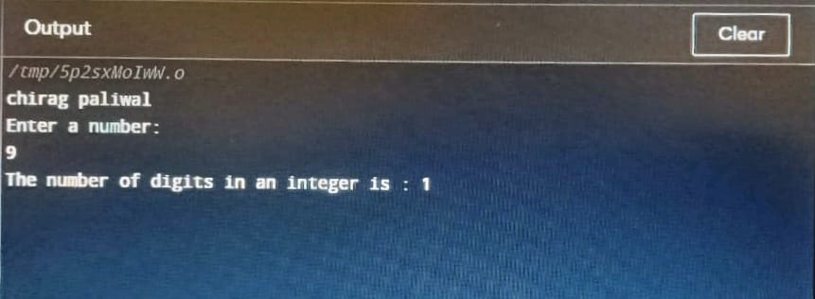

33.write a c program a number to find last digit of a number.

#include <stdio.h>

int main()

{

int n, lastDigit;

printf(“chirag paliwal\n):

printf("Enter any number: ");

scanf("%d", &n);

lastDigit = n % 10;

printf("Last digit = %d", lastDigit);

return 0;

}

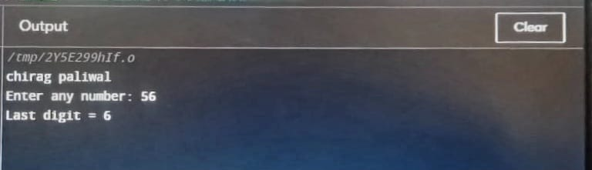

34.write a c program to find sum of first and last digit.

#include <stdio.h>

int main()

{

int num, sum=0, firstDigit, lastDigit;

printf("chirag paliwal\n");

printf("Enter any number to find sum of first and last digit: ");

scanf("%d", &num);

lastDigit = num % 10;

firstDigit = num;

while(num >= 10)

{

num = num / 10;

}

firstDigit = num;

sum = firstDigit + lastDigit;

printf("Sum of first and last digit = %d", sum);

return 0;

}

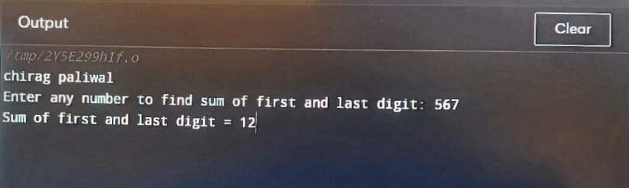

35 . write a c program swap first and last digit of number.

#include <stdio.h>

#include <math.h>

int main()

{

int n,firstDigit, lastDigit,digits, swappedNum;

printf("chirag paliwal\n");

printf("Enter number = ");

scanf("%d", &n);

lastDigit = n % 10;

digits = (int)log10(n);

firstDigit = (int) (n / pow(10, digits));

swappedNum = lastDigit;

swappedNum *= (int) round(pow(10, digits));

swappedNum += n % ((int)round(pow(10, digits)));

swappedNum -= lastDigit;

swappedNum += firstDigit;

printf("Number after swapping first and last digit: %d", swappedNum);

return 0;

}

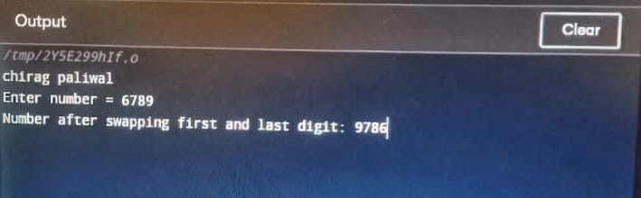

36 write a c program to calculate the sum of digit of number.

#include<stdio.h>

int main()

{

int n,sum=0,m;

printf("chirag paliwal\n");

printf("Enter a number:");

scanf("%d",&n);

while(n>0)

{

m=n%10;

sum=sum+m;

n=n/10;

}

printf("Sum is=%d",sum);

return 0;

}

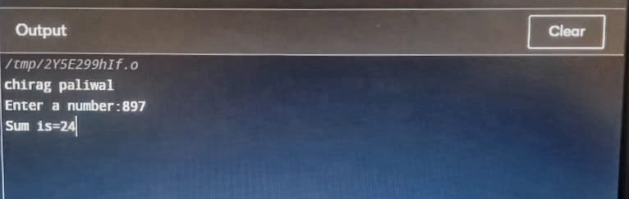

37 write c program, to to calculate product of digits of numbers

#include<stdio.h>

int main()

{

int num, rem, prod = 1;

printf("chirag paliwal\n");

printf("Enter a number: ");

scanf("%d", &num);

while(num != 0)

{

rem = num % 10;

prod *= rem;

num /= 10;

}

printf("%d", prod);

return 0;

}

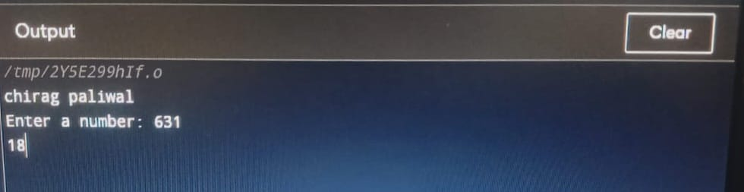

38.write a c program to enter a number and print it reverse.

#include<stdio.h>

int main()

{

int n, reverse=0, rem;

printf("chirag paliwal\n");

printf("Enter a number: ");

scanf("%d", &n);

while(n!=0)

{

rem=n%10;

reverse=reverse*10+rem;

n/=10;

}

printf("Reversed Number: %d",reverse);

return 0;

}

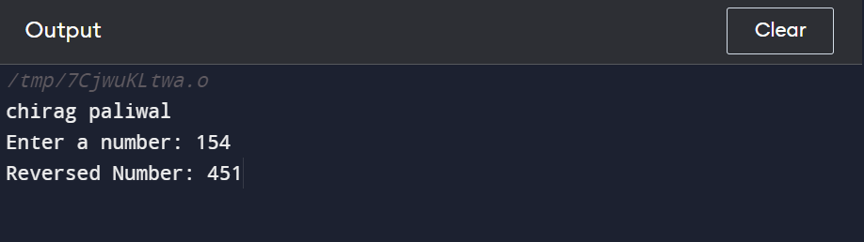

39.write a c program to check whether a number is palindrome or not.

#include <stdio.h>

int main() {

int n, reversed = 0, remainder, original;

printf("chirag paliwal\n");

printf("Enter an integer: ");

scanf("%d", &n);

original = n;

while (n != 0) {

remainder = n % 10;

reversed = reversed * 10 + remainder;

n /= 10;

}

if (original == reversed)

printf("%d is a palindrome.", original);

else

printf("%d is not a palindrome.", original);

return 0;

}

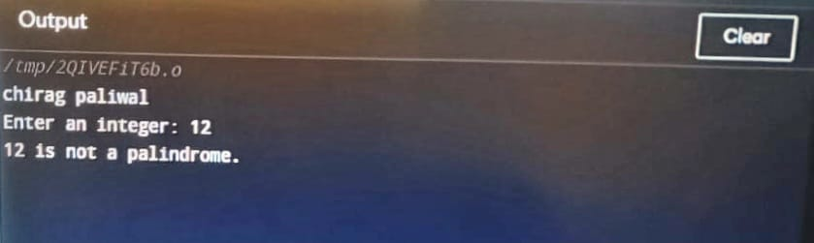

40.write a c program to find frequency of each digit in a given integer.

#include <stdio.h>

#define BASE 10

int main()

{

printf("chirag paliwal\n");

long long num, n;

int i, lastDigit;

int freq[BASE];

printf("Enter any number: ");

scanf("%lld", &num);

for(i=0; i<BASE; i++)

{

freq[i] = 0;

}

n = num;

while(n != 0)

{

lastDigit = n % 10;

n /= 10;

freq[lastDigit]++;

}

printf("Frequency of each digit in %lld is: \n", num);

for(i=0; i<BASE; i++)

{

printf("Frequency of %d = %d\n", i, freq[i]);

}

return 0;

}

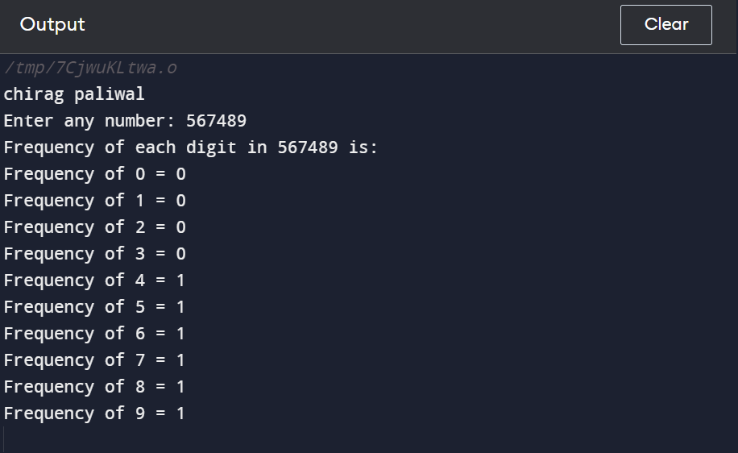

41. write a c program to enter a number and print in its words

#include <stdio.h>

int main()

{

int n, num = 0;

printf("chirag paliwal\n");

printf("Enter any number to print in words: ");

scanf("%d", &n);

while(n != 0)

{

num = (num * 10) + (n % 10);

n /= 10;

}

while(num != 0)

{

switch(num % 10)

{

case 0:

printf("Zero ");

break;

case 1:

printf("One ");

break;

case 2:

printf("Two ");

break;

case 3:

printf("Three ");

break;

case 4:

printf("Four ");

break;

case 5:

printf("Five ");

break;

case 6:

printf("Six ");

break;

case 7:

printf("Seven ");

break;

case 8:

printf("Eight ");

break;

case 9:

printf("Nine ");

break;

}

num = num / 10;

}

return 0;

}

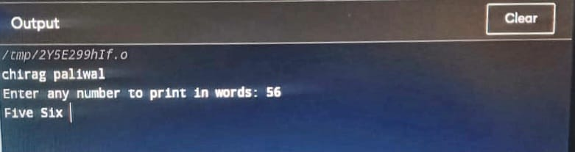

42.write a c program to print all ASCII value of all character.

#include <stdio.h>

int main()

{

int i;

printf("chirag paliwal\n");

for(i=0; i<=255; i++)

{

printf("ASCII value of character %c = %d\n", i, i);

}

return 0;

}

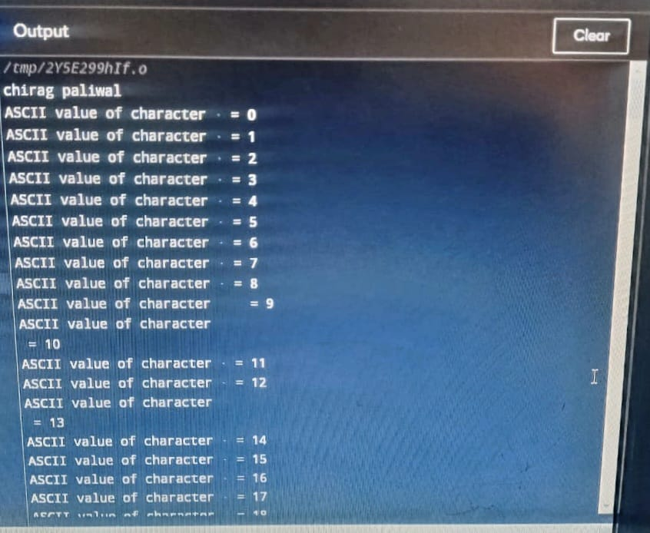

43. write a c program to find power of number using for loop?

#include <stdio.h>

int main()

{

int base, exponent;

long long power = 1;

int i;

printf("chirag paliwal\n");

printf("Enter base: ");

scanf("%d", &base);

printf("Enter exponent: ");

scanf("%d", &exponent);

for(i=1; i<=exponent; i++)

{

power = power * base;

}

printf("%d ^ %d = %lld", base, exponent, power);

return 0;

}

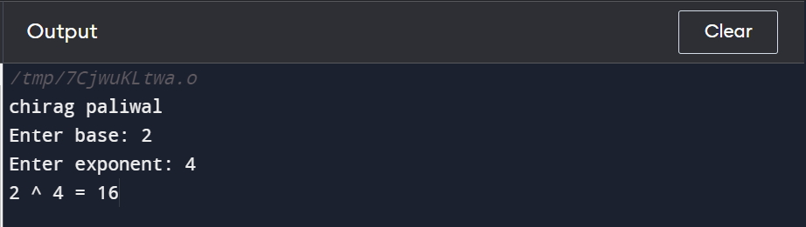

44.write a c program to find factors of number?

#include <stdio.h>

int main() {

int num, i;

printf(“chirag paliwal\n”);

printf("Enter a positive integer: ");

scanf("%d", &num);

printf("Factors of %d are: ", num);

for (i = 1; i <= num; ++i) {

if (num % i == 0) {

printf("%d ", i);

}

}

return 0;

}

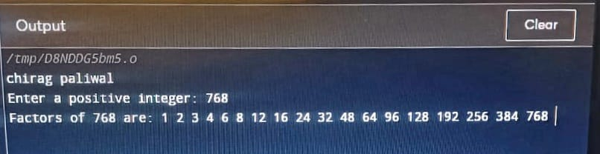

45. write a c program to calculate factorial of a number?

#include <stdio.h>

int main() {

int n, i;

unsigned long long fact = 1;

printf("chirag paliwal\n");

printf("Enter an integer: ");

scanf("%d", &n);

if (n < 0)

printf("Error! Factorial of a negative number doesn't exist.");

else {

for (i = 1; i <= n; ++i) {

fact *= i;

}

printf("Factorial of %d = %llu", n, fact);

}

return 0;

}

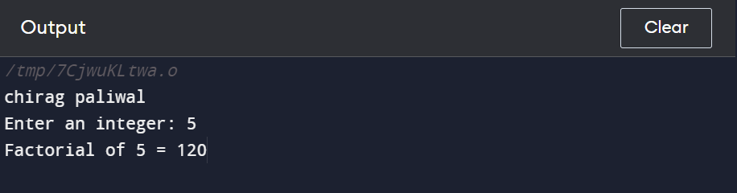

46.write a c program to find HCF of two numbers?

#include<stdio.h>

int main()

{

int num1 = 36, num2 = 60, hcf = 1;

printf("chirag paliwal\n");

for(int i = 1; i <= num1 || i <= num2; i++) {

if(num1 % i == 0 && num2 % i == 0)

hcf = i;

}

printf("The HCF: %d", hcf);

return 0;

}

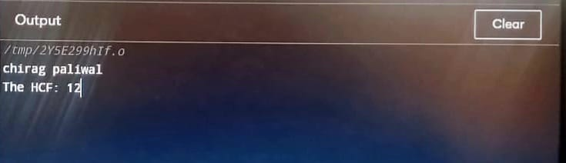

47. write a c program to find LCM of number?

#include <stdio.h>

int main() {

int n1, n2, max;

printf("chirag paliwal\n");

printf("Enter two positive integers: ");

scanf("%d %d", &n1, &n2);

max = (n1 > n2) ? n1 : n2;

while (1) {

if ((max % n1 == 0) && (max % n2 == 0)) {

printf("The LCM of %d and %d is %d.", n1, n2, max);

break;

}

++max;

}

return 0;

}

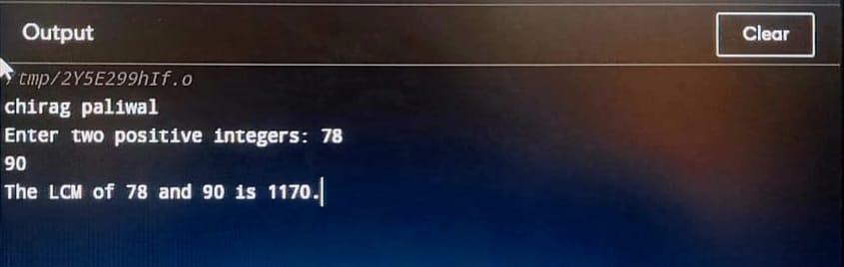

48.write a c program to check whether number prime or not?

#include <stdio.h>

int main() {

int n, i, flag = 0;

printf("chirag paliwal\n");

printf("Enter a positive integer: ");

scanf("%d", &n);

if (n == 0 || n == 1)

flag = 1;

for (i = 2; i <= n / 2; ++i) {

if (n % i == 0) {

flag = 1;

break;

}

}

if (flag == 0)

printf("%d is a prime number.", n);

else

printf("%d is not a prime number.", n);

return 0;

}

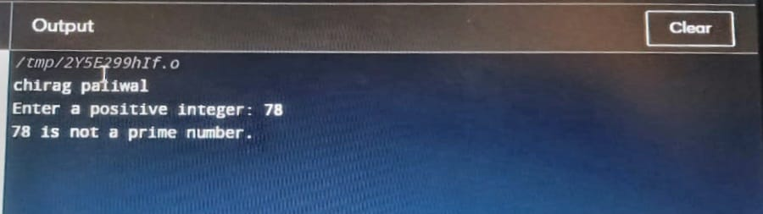

49.write a c program to print all prime number between 1 to n?

#include<stdio.h>

int main(){

int num,i,count,n;

printf("chirag paliwal\n");

printf("Enter max range: ");

scanf("%d",&n);

for(num = 1;num<=n;num++){

count = 0;

for(i=2;i<=num/2;i++){

if(num%i==0){

count++;

break;

}

}

if(count==0 && num!= 1)

printf("%d ",num);

}

return 0;

}

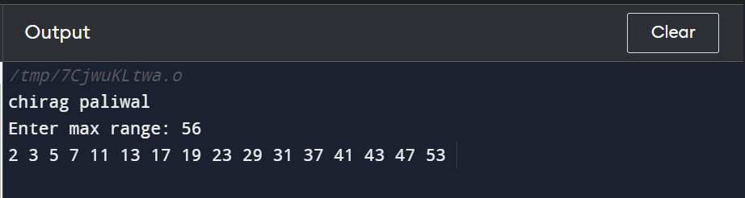

50. write a c program to find sum of all prime number between 1 to n?

#include <stdio.h>

int main()

{

int i, j, end, isPrime, sum=0;

printf("chirag paliwal\n");

printf("Find sum of all prime between 1 to : ");

scanf("%d", &end);

for(i=2; i<=end; i++)

{

isPrime = 1;

for(j=2; j<=i/2 ;j++)

{

if(i%j==0)

{

isPrime = 0;

break;

}

}

if(isPrime==1)

{

sum += i;

}

}

printf("Sum of all prime numbers between 1 to %d = %d", end, sum);

return 0;

}

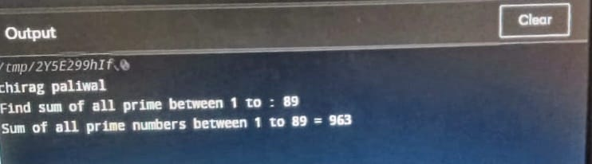

51.-write c program to find all prime factors of number?

#include <stdio.h>

int main()

{

int i, j, num, isPrime;

printf("chirag paliwal\n");

printf("Enter any number to print Prime factors: ");

scanf("%d", &num);

printf("All Prime Factors of %d are: \n", num);

for(i=2; i<=num; i++)

{

if(num%i==0)

{

isPrime = 1;

for(j=2; j<=i/2; j++)

{

if(i%j==0)

{

isPrime = 0;

break;

}

}

if(isPrime==1)

{

printf("%d, ", i);

}

}

}

return 0;

}

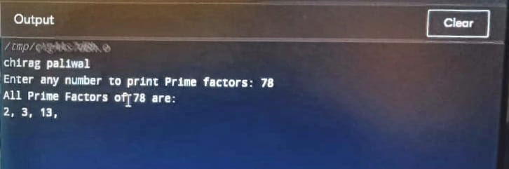

52. write a c program to check whether a number is Armstrong or not?

#include <stdio.h>

int main() {

int num, originalNum, remainder, result = 0;

printf("chirag paliwal\n");

printf("Enter a three-digit integer: ");

scanf("%d", &num);

originalNum = num;

while (originalNum != 0) {

remainder = originalNum % 10;

result += remainder * remainder * remainder;

originalNum /= 10;

}

if (result == num)

printf("%d is an Armstrong number.", num);

else

printf("%d is not an Armstrong number.", num);

return 0;

}

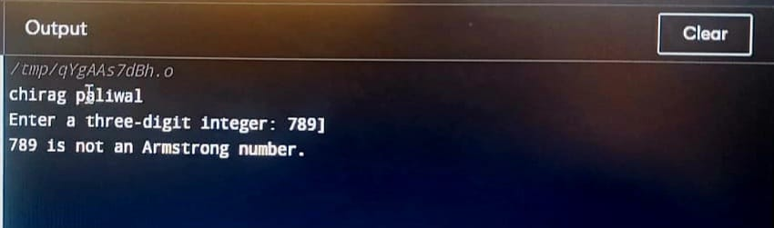

53. write a c program to print all Armstrong number between 1 to n?

#include <stdio.h>

#include <math.h>

int main()

{

int num, lastDigit, digits, sum, i, end;

printf("chirag paliwal\n");

printf("Enter upper limit: ");

scanf("%d", &end);

printf("Armstrong number between 1 to %d are: \n", end);

for(i=1; i<=end; i++)

{

sum = 0;

num = i;

digits = (int) log10(num) + 1;

while(num > 0)

{

lastDigit = num % 10;

sum = sum + ceil(pow(lastDigit, digits));

num = num / 10;

}

if(i == sum)

{

printf("%d, ", i);

}

}

return 0;

}

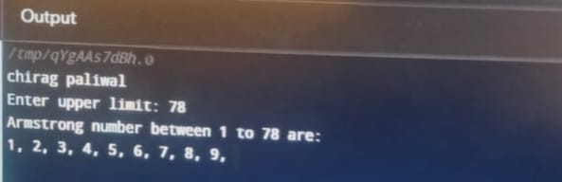

54. write a c program check whether a number is perfect or not?

#include <stdio.h>

int main()

{

int i, num, sum = 0;

printf("chirag paliwal\n");

printf("Enter any number to check perfect number: ");

scanf("%d", &num);

for(i = 1; i <= num / 2; i++)

{

if(num%i == 0)

{

sum += i;

}

}

if(sum == num && num > 0)

{

printf("%d is PERFECT NUMBER", num);

}

else

{

printf("%d is NOT PERFECT NUMBER", num);

}

return 0;

}

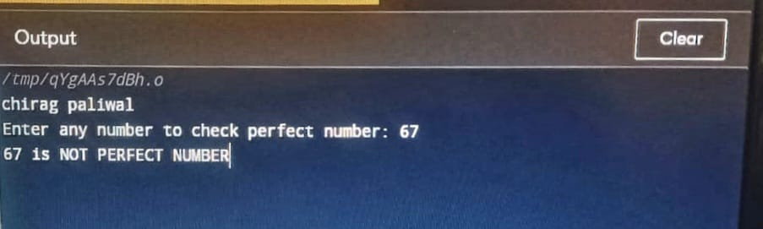

55.write a c program to print all perfect number between 1 to n?

#include <stdio.h>

int main()

{

int i, j, end, sum;

printf(":chirag paliwal\n");

printf("Enter upper limit: ");

scanf("%d", &end);

printf("All Perfect numbers between 1 to %d:\n", end);

for(i=1; i<=end; i++)

{

sum = 0;

for(j=1; j<i; j++)

{

if(i % j == 0)

{

sum += j;

}

}

if(sum == i)

{

printf("%d, ", i);

}

}

return 0;

}

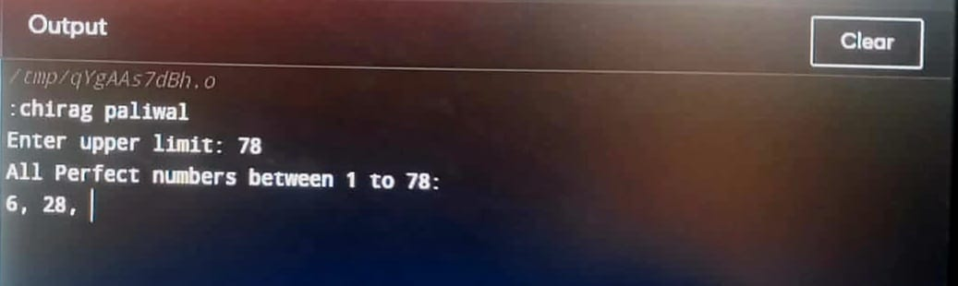

56. write a c program to check number is strong number or not?

#include <stdio.h>

int main()

{

int i, originalNum, num, lastDigit, sum;

long fact;

printf("chirag paliwal\n");

printf("Enter any number to check Strong number: ");

scanf("%d", &num);

originalNum = num;

sum = 0;

while(num > 0)

{

lastDigit = num % 10;

fact = 1;

for(i=1; i<=lastDigit; i++)

{

fact = fact * i;

}

sum = sum + fact;

num = num / 10;

}

if(sum == originalNum)

{

printf("%d is STRONG NUMBER", originalNum);

}

else

{

printf("%d is NOT STRONG NUMBER", originalNum);

}

return 0;

}

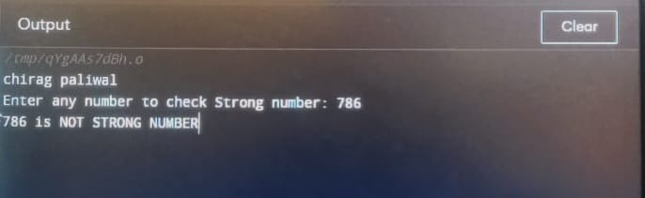

57. write a c program to print all strong number between 1 to n?

#include <stdio.h>

int main()

{

int i, j, cur, lastDigit, end;

long long fact, sum;

printf("chirag paliwal\n");

printf("Enter upper limit: ");

scanf("%d", &end);

printf("All Strong numbers between 1 to %d are:\n", end);

for(i=1; i<=end; i++)

{

cur = i;

sum = 0;

while(cur > 0)

{

fact = 1ll;

lastDigit = cur % 10;

for( j=1; j<=lastDigit; j++)

{

fact = fact * j;

}

sum += fact;

cur /= 10;

}

if(sum == i)

{

printf("%d, ", i);

}

return 0;

}

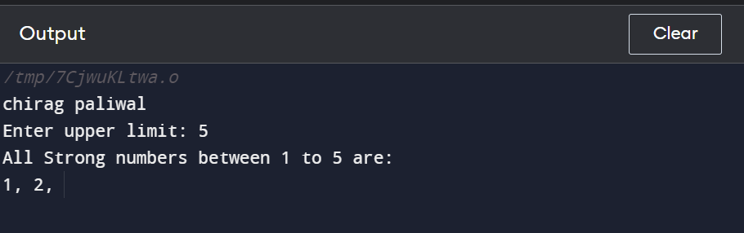

58.write a c program to print Fibonacci series up to n numbers?

#include <stdio.h>

int main()

{

int a, b, c, i, terms;

printf("chirag paliwal\n");

printf("Enter number of terms: ");

scanf("%d", &terms);

a = 0;

b = 1;

c = 0;

printf("Fibonacci terms: \n");

for(i=1; i<=terms; i++)

{

printf("%d, ", c);

a = b;

b = c;

c = a + b;

}

return 0;

}

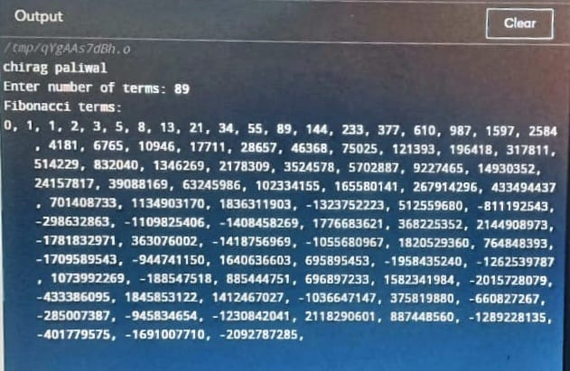

**59. write** a c program to find one’s complement of binary number?

#include <stdio.h>

#define SIZE 8

int main()

{

char binary[SIZE + 1], onesComp[SIZE + 1];

int i, error=0;

printf("chirag paliwal\n");

printf("Enter %d bit binary value: ", SIZE);

gets(binary);

for(i=0; i<SIZE; i++)

{

if(binary[i] == '1')

{

onesComp[i] = '0';

}

else if(binary[i] == '0')

{

onesComp[i] = '1';

}

else

{

printf("Invalid Input");

error = 1;

break;

}

}

onesComp[SIZE] = '\0';

if(error == 0)

{

printf("Original binary = %s\n", binary);

printf("Ones complement = %s", onesComp);

}

return 0;

}

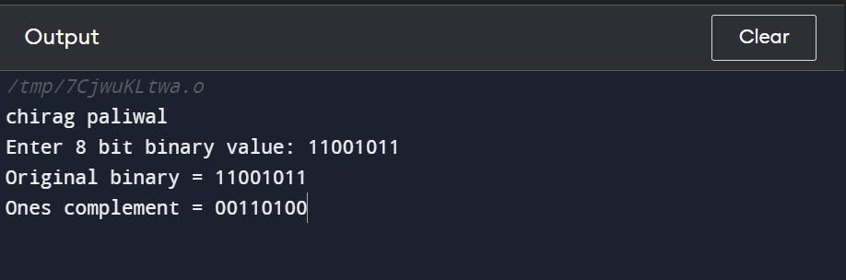

60. **. write** a c program to find two’s complement of binary number?

#include <stdio.h>

#define SIZE 8

int main()

{

char binary[SIZE + 1], onesComp[SIZE + 1], twosComp[SIZE + 1];

int i, carry=1;

printf("chirag paliwal\n");

printf("Enter %d bit binary value: ", SIZE);

gets(binary);

/* Find ones complement of the binary number */

for(i=0; i<SIZE; i++)

{

if(binary[i] == '1')

{

onesComp[i] = '0';

}

else if(binary[i] == '0')

{

onesComp[i] = '1';

}

}

onesComp[SIZE] = '\0';

for(i=SIZE-1; i>=0; i--)

{

if(onesComp[i] == '1' && carry == 1)

{

twosComp[i] = '0';

}

else if(onesComp[i] == '0' && carry == 1)

{

twosComp[i] = '1';

carry = 0;

}

else

{

twosComp[i] = onesComp[i];

}

}

twosComp[SIZE] = '\0';

printf("Original binary = %s\n", binary);

printf("Ones complement = %s\n", onesComp);

printf("Twos complement = %s\n", twosComp);

return 0;

}



61.write a c program to convert binary to octal number system?

#include <math.h>

#include <stdio.h>

int convert(long long bin);

int main() {

long long bin;

printf("chirag paliwal\n");

printf("Enter a binary number: ");

scanf("%lld", &bin);

printf("%lld in binary = %d in octal", bin, convert(bin));

return 0;

}

int convert(long long bin) {

int oct = 0, dec = 0, i = 0;

while (bin != 0) {

dec += (bin % 10) * pow(2, i);

++i;

bin /= 10;

}

i = 1;

while (dec != 0) {

oct += (dec % 8) * i;

dec /= 8;

i *= 10;

}

return oct;

}

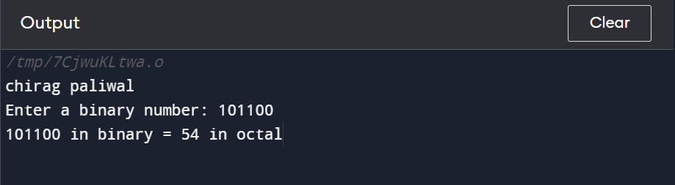

62. write a c program to convert binary to decimal number system?

#include <stdio.h>

#include <math.h>

int convert(long long);

int main() {

long long n;

printf("chirag paliwal\n");

printf("Enter a binary number: ");

scanf("%lld", &n);

printf("%lld in binary = %d in decimal", n, convert(n));

return 0;

}

int convert(long long n) {

int dec = 0, i = 0, rem;

while (n != 0) {

rem = n % 10;

n /= 10;

dec += rem * pow(2, i);

++i;

}

return dec;

}

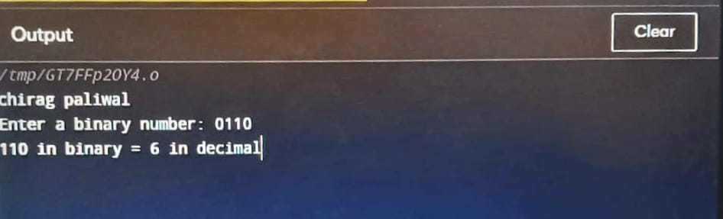

63. write a c program to convert binary to hexadecimal number system?

#include <stdio.h>

int main()

{

long int binaryval, hexadecimalval = 0, i = 1, remainder;

printf("chirag paliwal\n");

printf("Enter the binary number: ");

scanf("%ld", &binaryval);

while (binaryval != 0)

{

remainder = binaryval % 10;

hexadecimalval = hexadecimalval + remainder * i;

i = i * 2;

binaryval = binaryval / 10;

}

printf("Equivalent hexadecimal value: %lX", hexadecimalval);

return 0;

}

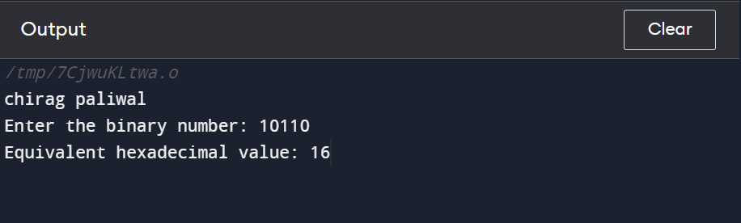

64. . write a c program to convert octal to decimal number system?

#include <stdio.h>

#include <math.h>

int convertDecimalToOctal(int decimalNumber);

int main() {

int decimalNumber;

printf("chirag paliwal\n");

printf("Enter a decimal number: ");

scanf("%d", &decimalNumber);

printf("%d in decimal = %d in octal", decimalNumber, convertDecimalToOctal(decimalNumber));

return 0;

}

int convertDecimalToOctal(int decimalNumber) {

int octalNumber = 0, i = 1;

while (decimalNumber != 0) {

octalNumber += (decimalNumber % 8) * i;

decimalNumber /= 8;

i *= 10;

}

return octalNumber;

}

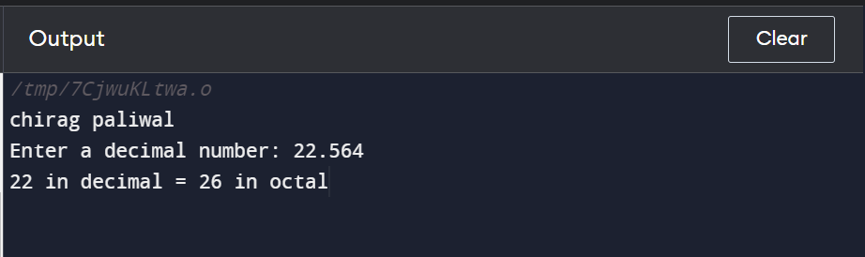

65. write a c program to convert octal to octal number system?

#include <stdio.h>

#include <math.h>

int convertDecimalToOctal(int decimalNumber);

int main() {

int decimalNumber;

printf("chirag paliwal\n");

printf("Enter a decimal number: ");

scanf("%d", &decimalNumber);

printf("%d in decimal = %d in octal", decimalNumber, convertDecimalToOctal(decimalNumber));

return 0;

}

int convertDecimalToOctal(int decimalNumber) {

int octalNumber = 0, i = 1;

while (decimalNumber != 0) {

octalNumber += (decimalNumber % 8) * i;

decimalNumber /= 8;

i *= 10;

}

return octalNumber;

}



66. write a c program to convert octal to hexadecimal number system?

#include <stdio.h>

#include <math.h>

int main()

{

int n, sum = 0;

printf("chirag paliwal\n");

printf("Enter the Octal Number :--> ");

scanf("%d", &n);

int i = 0;

while(n != 0)

{

int digit = n % 10;

sum = sum + (digit * pow(8,i));

n = n / 10;

i++;

}

printf("\nThe Decimal Number is :--> %d",sum);

int ans = 0,j = 0;

while(sum != 0)

{

int digit = sum % 16;

ans = ans + (digit * pow(10, j));

sum = sum / 16;

j++;

}

printf("\nThe Hexadecimal Number is :--> %d",ans);

return 0;

}

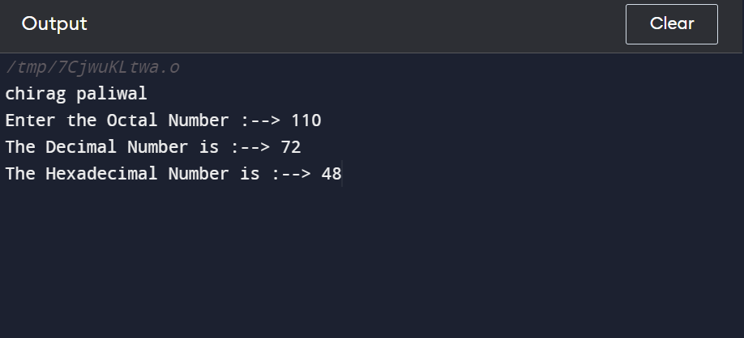

67. write a c program to convert decimal to binary number system?

#include <stdio.h>

#include <math.h>

int convert(long long);

int main() {

long long n;

printf("chirag paliwal\n");

printf("Enter a binary number: ");

scanf("%lld", &n);

printf("%lld in binary = %d in decimal", n, convert(n));

return 0;

}

int convert(long long n) {

int dec = 0, i = 0, rem;

while (n != 0) {

rem = n % 10;

n /= 10;

dec += rem * pow(2, i);

++i;

}

return dec;

}

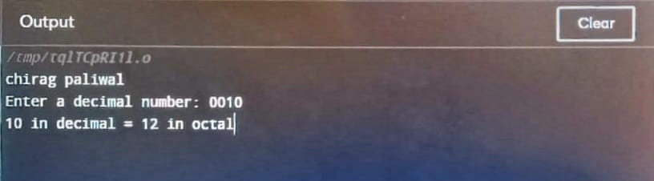

69. write a c program to convert decimal to hexadecimal number system?

#include<stdio.h>

int main()

{

int decnum, rem, i=0;

char hexnum[50];

printf("chirag paliwal\n");

printf("Enter any decimal number: ");

scanf("%d", &decnum);

while(decnum!=0)

{

rem = decnum%16;

if(rem<10)

rem = rem+48;

else

rem = rem+55;

hexnum[i] = rem;

i++;

decnum = decnum/16;

}

printf("\nEquivalent Value in Hexadecimal = ");

for(i=i-1; i>=0; i--)

printf("%c", hexnum[i]);

return 0;

}

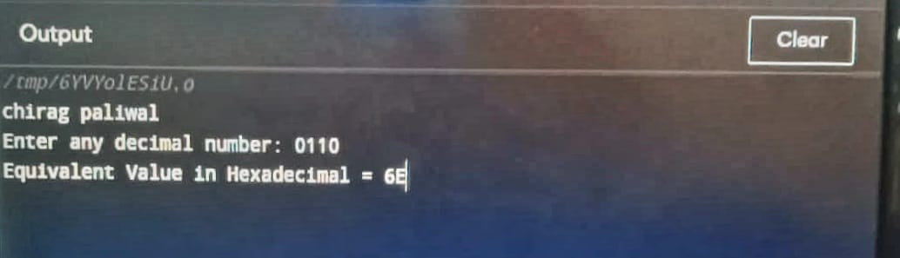

70.write a c program to convert hexadecimal to octal number system?

#include <stdio.h>

#include <math.h>

int main()

{

int n, ans = 0;

printf("chirag paliwal\n");

printf("Enter the Hexadecimal number :--> ");

scanf("%d", &n);

int i = 0;

while(n != 0)

{

int digit = n % 10;

ans = ans + (digit * pow(16, i));

n = n / 10;

i++;

}

printf("\nThe Decimal Number is :--> %d", ans);

int j = 0, ans2 = 0;

while(ans != 0)

{

int digit = ans%8;

ans2 = ans2 + (digit * pow(10, j));

ans = ans / 8;

j++;

}

printf("\nThe Octal Number is :--> %d", ans2);

return 0;

}

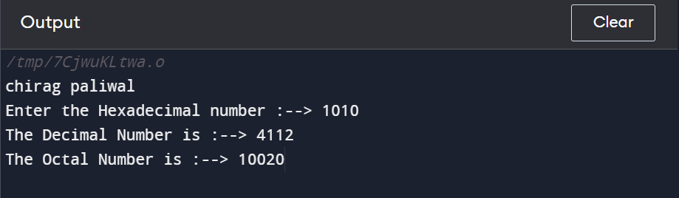

71. write a c program to convert hexadecimal to binary number system?

#include <stdio.h>

#include <math.h>

int main()

{

int n, ans = 0, B[100];

printf("chirag paliwal\n");

printf("Enter the Hexadecimal Number :--> ");

scanf("%d", &n);

int i = 0;

while(n != 0)

{

int digit = n % 10;

ans = ans + (digit * pow(16, i));

n = n / 10;

i++;

}

printf("\nThe Decimal Number is :--> %d", ans);

int j = 0, k;

while(ans > 0)

{

B[j] = ans % 2;

ans = ans >> 1;

j++;

}

printf("\nThe Binary Number is :--> ");

for(k = j - 1; k >= 0; k--)

{

printf("%d",B[k]);

}

return 0;

}

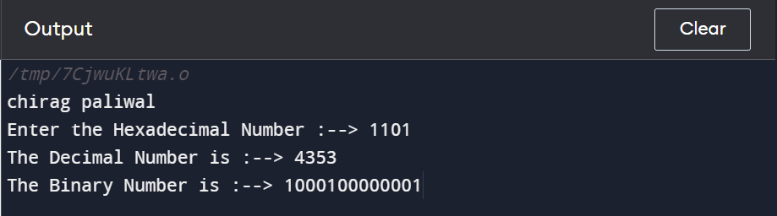

72. write a c program to convert hexadecimal to decimal number system?

#include <stdio.h>

#include <math.h>

int main()

{

int n, ans = 0;

printf("chirag paliwal\n");

printf("Enter the Hexadecimal number :--> ");

scanf("%d", &n);

int i = 0;

while(n != 0)

{

int digit = n % 10;

ans = ans + (digit* pow(16,i));

n = n / 10;

i++;

}

printf("The Decimal number is :--> %d",ans);

return 0;

}

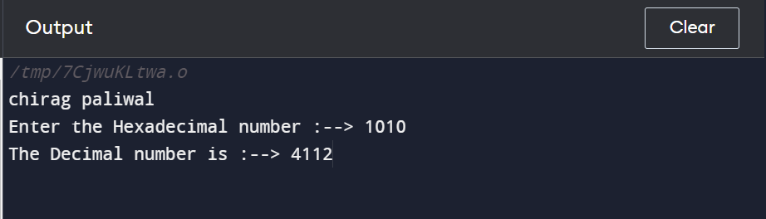

**Pattern exercise**

1 . **number pattern programs** :- write c program to print given number pattern?

**Square number pattern**

111111

111111

111111

111111

#include <stdio.h>

int main()

{

int rows, cols, i, j;

printf("chirag paliwal\n");

printf("Enter number of rows: ");

scanf("%d", &rows);

printf("Enter number of columns: ");

scanf("%d", &cols);

for(i=1; i<=rows; i++)

{

for(j=1; j<=cols; j++)

{

printf("1");

}

printf("\n");

}

return 0;

}

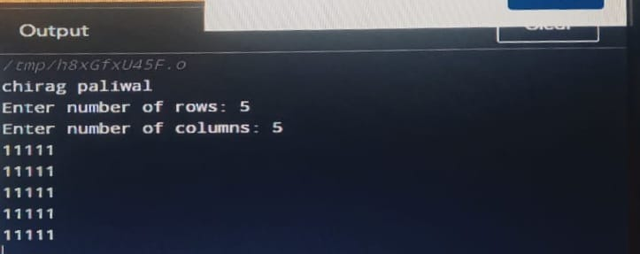

2.**number pattern 1**

11111

00000

11111

00000

#include <stdio.h>

int main()

{

int rows, cols, i, j;

printf("chirag paliwal\n");

printf("Enter number of rows: ");

scanf("%d", &rows);

printf("Enter number of columns: ");

scanf("%d", &cols);

for(i=1; i<=rows; i++)

{

for(j=1; j<=cols; j++)

{

if(i%2 == 1)

{

printf("1");

}

else

{

printf("0");

}

}

printf("\n");

}

return 0;

}

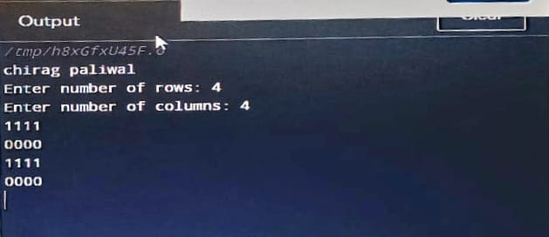

**3. number pattern**

01010

01010

01010

01010

#include <stdio.h>

int main()

{

int rows, cols, i, j;

printf("chirag paliwal\n");

printf("Enter number of rows: ");

scanf("%d", &rows);

printf("Enter number of columns: ");

scanf("%d", &cols);

for(i=1; i<=rows; i++)

{

for(j=1; j<=cols; j++)

{

if(j%2 == 1)

{

printf("0");

}

else

{

printf("1");

}

}

printf("\n");

}

return 0;

}

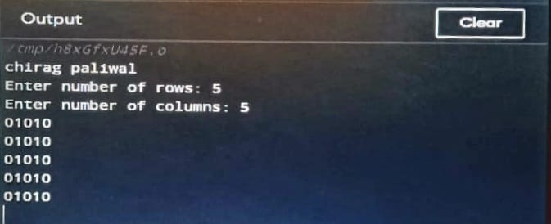

4. **number pattern**

11111

11111

11011

11111

11111

#include <stdio.h>

int main()

{

int rows, cols, i, j;

int centerRow, centerCol;

printf("chirag paliwal\n");

printf("Enter number of rows: ");

scanf("%d", &rows);

printf("Enter number of columns: ");

scanf("%d", &cols);

centerRow = (rows + 1) / 2;

centerCol = (cols + 1) / 2;

for(i=1; i<=rows; i++)

{

for(j=1; j<=cols; j++)

{

if(centerCol == j && centerRow == i)

{

printf("0");

}

else if(cols%2 == 0 && centerCol+1 == j)

{

if(centerRow == i || (rows%2 == 0 && centerRow+1 == i))

printf("0");

else

printf("1");

}

else if(rows%2 == 0 && centerRow+1 == i)

{

if(centerCol == j || (cols%2 == 0 && centerCol+1 == j))

printf("0");

else

printf("1");

}

else

{

printf("1");

}

}

printf("\n");

}

return 0;

}

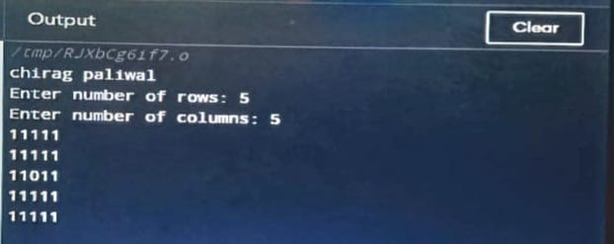

**5.number pattern**

10101

01010

10101

01010

10101

#include <stdio.h>

int main()

{

int rows, cols, i, j, k;

printf("chirag paliwal\n");

printf("Enter number of rows: ");

scanf("%d", &rows);

printf("Enter number of columns: ");

scanf("%d", &cols);

k = 1;

for(i=1; i<=rows; i++)

{

for(j=1; j<=cols; j++)

{

if(k == 1)

{

printf("1");

}

else

{

printf("0");

}

k *= -1;

}

if(cols % 2 == 0)

{

k *= -1;

}

printf("\n");

}

return 0;

}

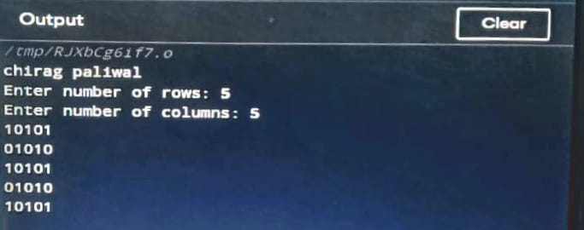

**2. star pattern programs:-**

**Full Pyramid star pattern**

#include <stdio.h>

int main()

{

int rows = 5;

printf("chirag paliwal\n");

for (int i = 0; i < rows; i++) {

for (int j = 0; j < 2 * (rows - i) - 1; j++) {

printf(" ");

}

for (int k = 0; k < 2 * i + 1; k++) {

printf("* ");

}

printf("\n");

}

return 0;

}

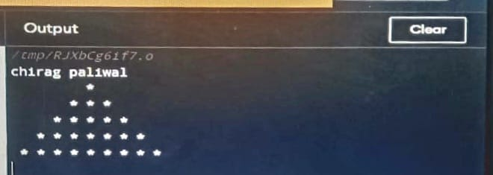

2**.hollow pyramid star pattern**

#include <stdio.h>

int main()

{

int rows = 5;

printf("chirag paliwal\n");

for (int i = 0; i < rows; i++) {

for (int j = 0; j < 2 * (rows - i) - 1; j++) {

printf(" ");

}

for (int k = 0; k < 2 * i + 1; k++) {

if (k == 0 || k == 2 * i || i == rows - 1) {

printf("* ");

}

else {

printf(" ");

}

}

printf("\n");

}

return 0;

}

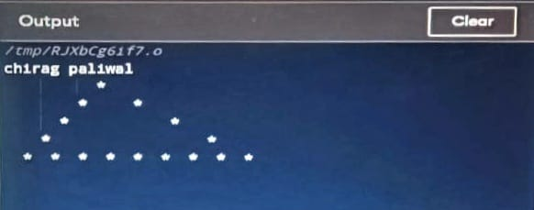

3. **inverted pyramid strar pattern**

#include <stdio.h>

int main()

{

int i, j, rows;

printf("chirag paliwal\n");

printf("Enter number of rows: ");

scanf("%d", &rows);

for(i=1; i<=rows; i++)

{

for(j=1; j<i; j++)

{

printf(" ");

}

for(j=1; j<=(rows*2 - (2*i-1)); j++)

{

if(i==1 || j==1 || j==(rows*2 - (2*i - 1)))

{

printf("*");

}

else

{

printf(" ");

}

}

printf("\n");

}

return 0;

}

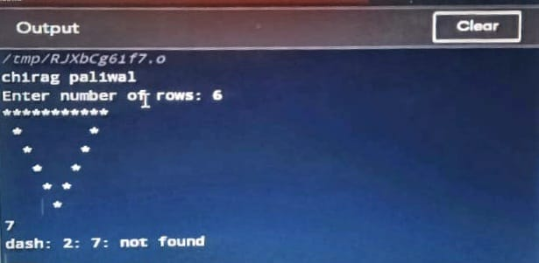

5.**half diamond star pattern**

#include<stdio.h>

int main()

{

int i, j, N, columns;

printf("chirag paliwal\n");

printf("Enter number of columns:");

scanf("%d",&N);

columns=1;

for(i=1;i<N*2;i++)

{

for(j=1; j<=columns; j++)

{

printf("*");

}

if(i < N)

{

columns++;

}

else

{

columns--;

}

printf("\n");

}

return 0;

}

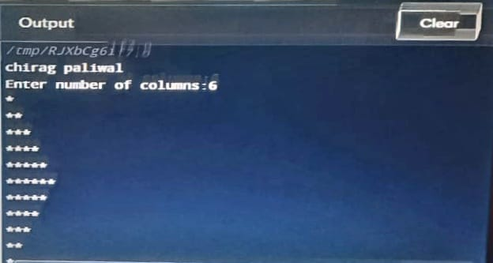

**If-Else statement-**

1. Write a C program to find the maximum of two numbers.

#include<stdio.h>

int main()

{

int num1,num2,max;

printf("Enter the 1st value=\n");

scanf("%d",&num1);

printf("Enter the 2nd value=\n");

scanf("%d",&num2);

if(num1>num2)

{

max=num1;

printf("\nChiirag Paliwal");

printf("\nMaximum num is %d",max);

}

else if(num1<num2)

{

max=num2;

printf("\nChiirag Paliwal");

printf("\nMaximum num is %d",max);

}

else

{

printf("Chiirag Paliwal");

printf("\nNumbers are equal");

}

}

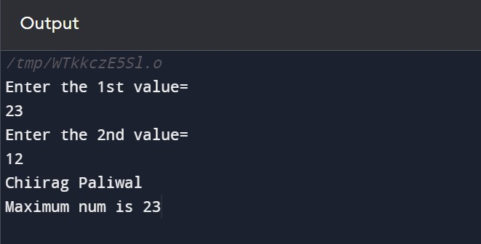

1. Write a C program to find maximum between three numbers.

#include <stdio.h>

int main()

{

int num1, num2, num3, max;

printf("\n chiirag paliwal\n");

printf("Enter three numbers: ");

scanf("%d%d%d", &num1, &num2, &num3);

if(num1 > num2)

{

if(num1 > num3)

{

max = num1;

}

else

{

max = num3;

}

}

else

{

if(num2 > num3)

{

max = num2;

}

else

{

max = num3;

}

}

printf("Maximum among all three numbers = %d", max);

return 0;

}

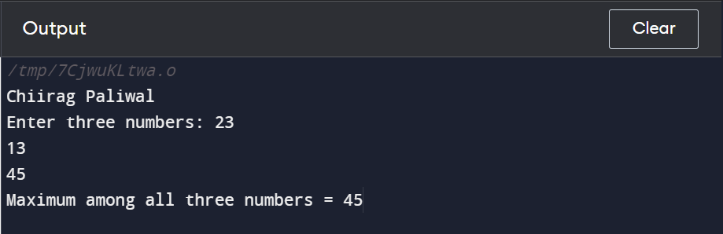

1. Write a C program to check whether a number is negative, positive or zero.

#include<stdio.h>

int main()

{

int num;

printf("\nChiirag Paliwal");

printf("Enter the number=\n");

scanf("%d",&num);

if(num>0)

{

printf("\npositive number");

}

else if(num<0)

{

printf("\nNegative number");

}

else

{

printf("\n Number is zero");

}

return 0;

}

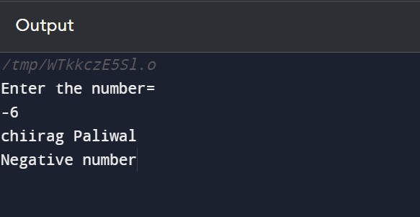

4.Write a C program to check whether a number is divisible by 5 and 11 or not.

#include<stdio.h>

int main()

{

int num;

printf("Enter the number=\n");

scanf("%d",&num);

printf("\nChiirag Paliwal");

if(num%5==0 && num%11==0)

{

printf("\nNumber is divisible");

}

else

{

printf("\nNumber is not divisible");

}

return 0;

}

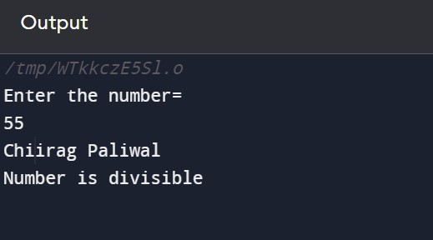

5.Write a C program to check whether a number is even or odd.

#include<stdio.h>

int main()

{

int num;

printf("\nChiirag Paliwal\n");

printf("Enter the number=\n");

scanf("%d",&num);

if(num==1)

{

printf("neither odd nor even");

}

else if(num%2==0)

{

printf("Even number");

}

else

{

printf("Odd number");

}

return 0;

}

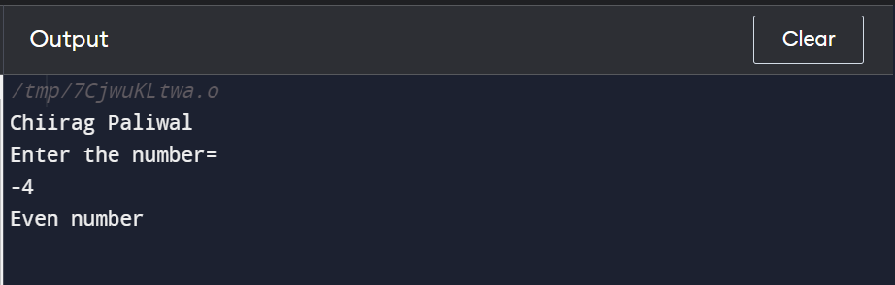

6. Write a C program to check whether a year is a leap year or not.

#include <stdio.h>

int main() {

int year;

printf("\nChiirag Paliwal\n");

printf("Enter a year: ");

scanf("%d", &year);

if (year % 400 == 0) {

printf("%d is a leap year.", year);

}

else if (year % 100 == 0) {

printf("%d is not a leap year.", year);

}

else if (year % 4 == 0) {

printf("%d is a leap year.", year);

}

else {

printf("%d is not a leap year.", year);

}

return 0;

}

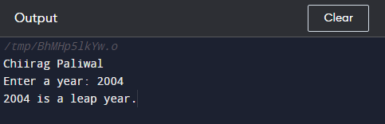

8. Write a C program to input any alphabet and check whether it is vowel or consonant.

#include <stdio.h>

int main() {

char c;

int lowercase_vowel, uppercase_vowel;

printf("\nChiirag Paliwal\n");

printf("Enter an alphabet: ");

scanf("%c", &c);

lowercase_vowel = (c == 'a' || c == 'e' || c == 'i' || c == 'o' || c == 'u');

uppercase_vowel = (c == 'A' || c == 'E' || c == 'I' || c == 'O' || c == 'U');

if (lowercase_vowel || uppercase_vowel)

printf("%c is a vowel.", c);

else

printf("%c is a consonant.", c);

return 0;

}

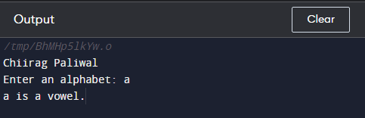

8. Write a c program to input any character and check whether it is a alphabet,digit or special character.

#include <stdio.h>

int main()

{

char ch;

printf("\nChiirag Paliwal\n");

printf("Enter any character: ");

scanf("%c", &ch);

if((ch >= 'a' && ch <= 'z') || (ch >= 'A' && ch <= 'Z'))

{

printf("'%c' is alphabet.", ch);

}

else if(ch >= '0' && ch <= '9')

{

printf("'%c' is digit.", ch);

}

else

{

printf("'%c' is special character.", ch);

}

return 0;

}

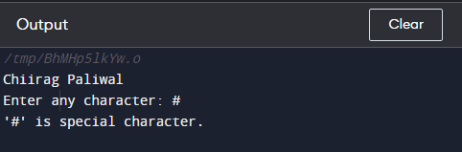

10. Write a c program to heck whether a character is uppercase or lowercase alphabet.

#include <stdio.h>

int main()

{

char ch;

printf("\nChiirag Paliwal\n");

printf("Enter any character: ");

scanf("%c", &ch)

if(ch >= 'A' && ch <= 'Z')

{

printf("'%c' is uppercase alphabet.", ch);

}

else if(ch >= 'a' && ch <= 'z')

{

printf("'%c' is lowercase alphabet.", ch);

}

else

{

printf("'%c' is not an alphabet.", ch);

}

return 0;

}

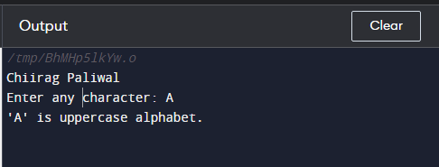

11. Write a c program to input week number and print week day.

#include <stdio.h>

int main()

{

int week;

printf("\nChiirag Paliwal\n");

printf("Enter week number (1-7): ");

scanf("%d", &week);

if(week == 1)

{

printf("Monday");

}

else if(week == 2)

{

printf("Tuesday");

}

else if(week == 3)

{

printf("Wednesday");

}

else if(week == 4)

{

printf("Thursday");

}

else if(week == 5)

{

printf("Friday");

}

else if(week == 6)

{

printf("Saturday");

}

else if(week == 7)

{

printf("Sunday");

}

else

{

printf("Invalid Input! Please enter week number between 1-7.");

}

return 0;

}

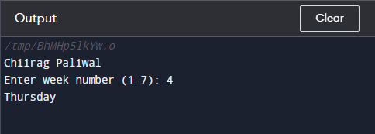

13. Write a c program to count total number of notes in a given amount.

#include <stdio.h>

int main()

{

int amount;

printf("\nChiirag Paliwal\n");

int note500, note100, note50, note20, note10, note5, note2, note1;

note500 = note100 = note50 = note20 = note10 = note5 = note2 = note1 = 0;

printf("Enter amount: ");

scanf("%d", &amount);

if(amount >= 500)

{

note500 = amount/500;

amount -= note500 * 500;

}

if(amount >= 100)

{

note100 = amount/100;

amount -= note100 * 100;

}

if(amount >= 50)

{

note50 = amount/50;

amount -= note50 * 50;

}

if(amount >= 20)

{

note20 = amount/20;

amount -= note20 * 20;

}

if(amount >= 10)

{

note10 = amount/10;

amount -= note10 * 10;

}

if(amount >= 5)

{

note5 = amount/5;

amount -= note5 * 5;

}

if(amount >= 2)

{

note2 = amount /2;

amount -= note2 * 2;

}

if(amount >= 1)

{

note1 = amount;

}

/* Print required notes */

printf("Total number of notes = \n");

printf("500 = %d\n", note500);

printf("100 = %d\n", note100);

printf("50 = %d\n", note50);

printf("20 = %d\n", note20);

printf("10 = %d\n", note10);

printf("5 = %d\n", note5);

printf("2 = %d\n", note2);

printf("1 = %d\n", note1);

return 0;

}

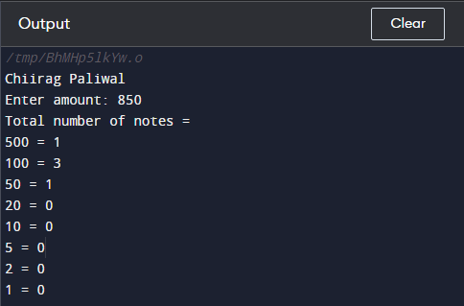

16. Write a c program to input angles of a triangle and check whether a triangle is valid or not.

#include <stdio.h>

int main()

{

int angle1, angle2, angle3, sum;

printf("\nChiirag Paliwal\n");

printf("Enter three angles of triangle: \n");

scanf("%d%d%d", &angle1, &angle2, &angle3);

sum = angle1 + angle2 + angle3;

if(sum == 180 && angle1 > 0 && angle2 > 0 && angle3 > 0)

{

printf("Triangle is valid.");

}

else

{

printf("Triangle is not valid.");

}

return 0;

}

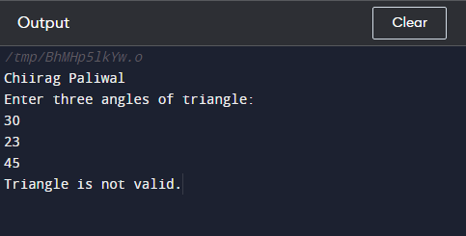

18. Write a C program to check whether the triangle is equilateral, isosceles or scalene triangle.

#include <stdio.h>

int main()

{

int side1, side2, side3;

printf("\nChiirag Paliwal\n");

printf("Enter three sides of triangle: ");

scanf("%d%d%d", &side1, &side2, &side3);

if(side1==side2 && side2==side3)

{

printf("Equilateral triangle.");

}

else if(side1==side2 || side1==side3 || side2==side3)

{

printf("Isosceles triangle.");

}

else

{

printf("Scalene triangle.");

}

return 0;

}

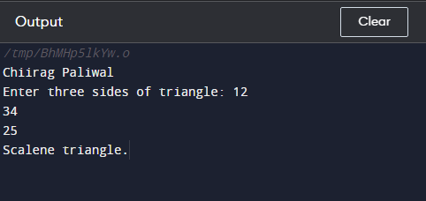

19. Write a c program to find all roots of a quadratic equation.

#include <math.h>

#include <stdio.h>

int main() {

double a, b, c, discriminant, root1, root2, realPart, imagPart;

printf("\nChiirag Paliwal\n");

printf("Enter coefficients a, b and c: ");

scanf("%lf %lf %lf", &a, &b, &c);

discriminant = b * b - 4 * a * c;

if (discriminant > 0) {

root1 = (-b + sqrt(discriminant)) / (2 * a);

root2 = (-b - sqrt(discriminant)) / (2 * a);

printf("root1 = %.2lf and root2 = %.2lf", root1, root2);

}

else if (discriminant == 0) {

root1 = root2 = -b / (2 * a);

printf("root1 = root2 = %.2lf;", root1);

}

else {

realPart = -b / (2 * a);

imagPart = sqrt(-discriminant) / (2 * a);

printf("root1 = %.2lf+%.2lfi and root2 = %.2f-%.2fi", realPart, imagPart, realPart, imagPart);

}

return 0;

}

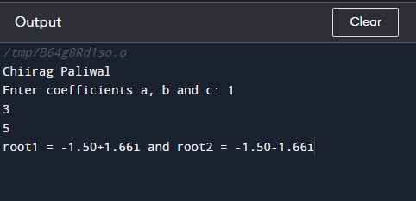

20.Write a C program to calculate profit or loss.

#include <stdio.h>

int main()

{

int cp,sp, amt;

printf("\nChiirag Paliwal\n");

printf("Enter cost price: ");

scanf("%d", &cp);

printf("Enter selling price: ");

scanf("%d", &sp);

if(sp > cp)

{

amt = sp - cp;

printf("Profit = %d", amt);

}

else if(cp > sp)

{

amt = cp - sp;

printf("Loss = %d", amt);

}

else

{

printf("No Profit No Loss.");

}

return 0;

}

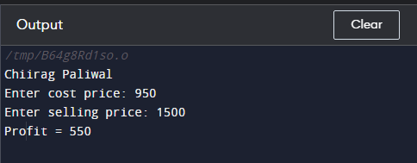

20. Write a C program to input marks of five subjects Physics, Chemistry, Biology, Mathematics and Computer, calculate percentage and grade according to given conditions:  
If percentage >= 90% : Grade A  
If percentage >= 80% : Grade B  
If percentage >= 70% : Grade C  
If percentage >= 60% : Grade D  
If percentage >= 40% : Grade E  
If percentage < 40% : Grade F

#include <stdio.h>

int main()

{

int phy, chem, bio, math, comp;

float per;

printf("\nChiirag Paliwal\n");

printf("Enter five subjects marks: ");

scanf("%d%d%d%d%d", &phy, &chem, &bio, &math, &comp);

per = (phy + chem + bio + math + comp) / 5.0;

printf("Percentage = %.2f\n", per);

if(per >= 90)

{

printf("Grade A");

}

else if(per >= 80)

{

printf("Grade B");

}

else if(per >= 70)

{

printf("Grade C");

}

else if(per >= 60)

{

printf("Grade D");

}

else if(per >= 40)

{

printf("Grade E");

}

else

{

printf("Grade F");

}

return 0;

}

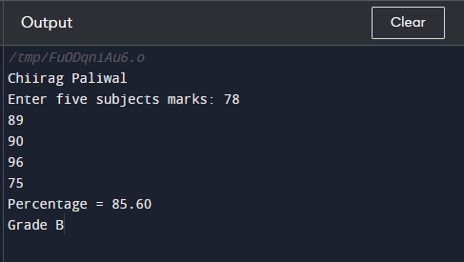

22. Write a C program to input basic salary of an employee and calculate gross salary according to given conditions.  
Basic Salary <= 10000 : HRA = 20%, DA = 80%  
Basic Salary is between 10001 to 20000 : HRA = 25%, DA = 90%  
Basic Salary >= 20001 : HRA = 30%, DA = 95%

#include <stdio.h>

int main()

{

float basic, gross, da, hra;

printf("\nChiirag Paliwal\n");

printf("Enter basic salary of an employee: ");

scanf("%f", &basic);

if(basic <= 10000)

{

da = basic * 0.8;

hra = basic * 0.2;

}

else if(basic <= 20000)

{

da = basic * 0.9;

hra = basic * 0.25;

}

else

{

da = basic * 0.95;

hra = basic * 0.3;

}

gross = basic + hra + da;

printf("GROSS SALARY OF EMPLOYEE = %.2f", gross);

return 0;

}

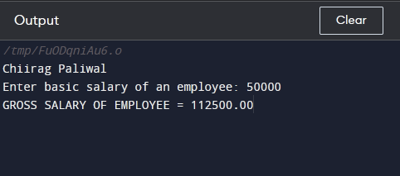

23. Write a C program to input electricity unit charge and calculate the total electricity bill according to the given condition:  
For first 50 units Rs. 0.50/unit  
For next 100 units Rs. 0.75/unit  
For next 100 units Rs. 1.20/unit  
For unit above 250 Rs. 1.50/unit  
An additional surcharge of 20% is added to the bill.

#include <stdio.h>

int main()

{

int unit;

float amt, total_amt, sur_charge;

printf("\nChiirag Paliwal\n");

printf("Enter total units consumed: ");

scanf("%d", &unit);

if(unit <= 50)

{

amt = unit * 0.50;

}

else if(unit <= 150)

{

amt = 25 + ((unit-50) * 0.75);

}

else if(unit <= 250)

{

amt = 100 + ((unit-150) * 1.20);

}

else

{

amt = 220 + ((unit-250) * 1.50);

}

sur_charge = amt * 0.20;

total_amt = amt + sur_charge;

printf("Electricity Bill = Rs. %.2f", total_amt);

return 0;

}

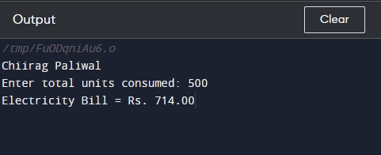

24. Write a C program to convert specified days into years, weeks and days.

#include <stdio.h>

int main()

{

int days, years, weeks;

printf("\nChiirag Paliwal\n");

days = 1329;

years = days/365;

weeks = (days % 365)/7;

days = days- ((years*365) + (weeks*7));

printf("Years: %d\n", years);

printf("Weeks: %d\n", weeks);

printf("Days: %d \n", days);

return 0;

}

